User Manual
Safeguard Information System

Table of Contents
Login 3
Dashboard 4
Administration 4
Modules 5
User Role 5
User Permission 6
User 7
Organization Type 8
Organization 8
SIS Related 9
Pages 9
Categories 11
Images 11
Albums 12
Documents Type 13
Documents 14
Feedback and Complaint Management 16
Complaint/Grievance Type 16
Complaint/Grievance 17
Principle Criteria and Indicator 21
Principle 21
Criteria 24
Indicator 25
Verifier 26
International Safeguard Policies 27
Glossary 28
Project 29

Login
To access admin dashboard of SIS, visit http://sis.redd.gov.np/admindashboard. On doing so a login page will appear as shown in image below.
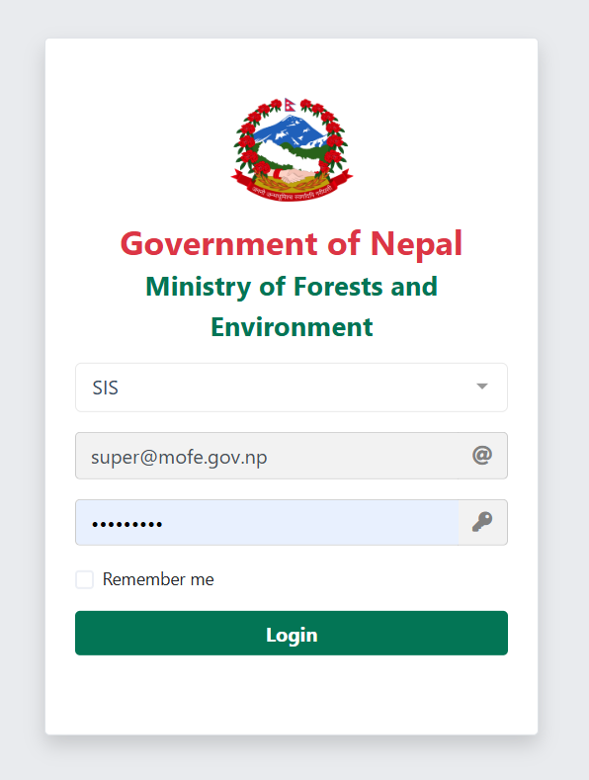

Provide the username and password. On successful login, user will be redirected to dashboard as in figure below. Based on user level different information will be displayed in the dashboard and navigation bar.

Dashboard
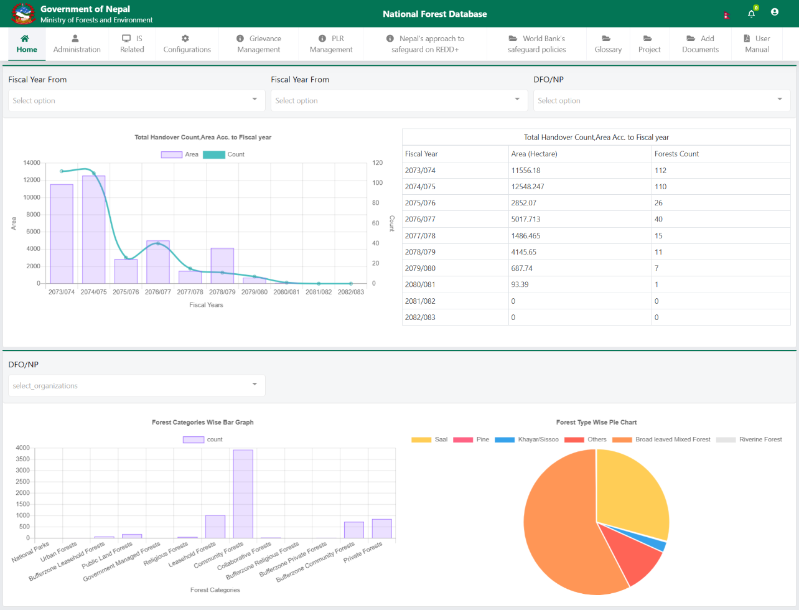

Administration
Administration section of the system is related to user management. On this section, authorized user can perform CRUD operation over Modules, User Role, Permission, Users, Organization Type and Organization. User can access this section by click on the navigation bar menu.
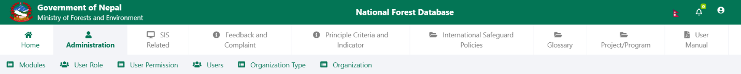

Modules
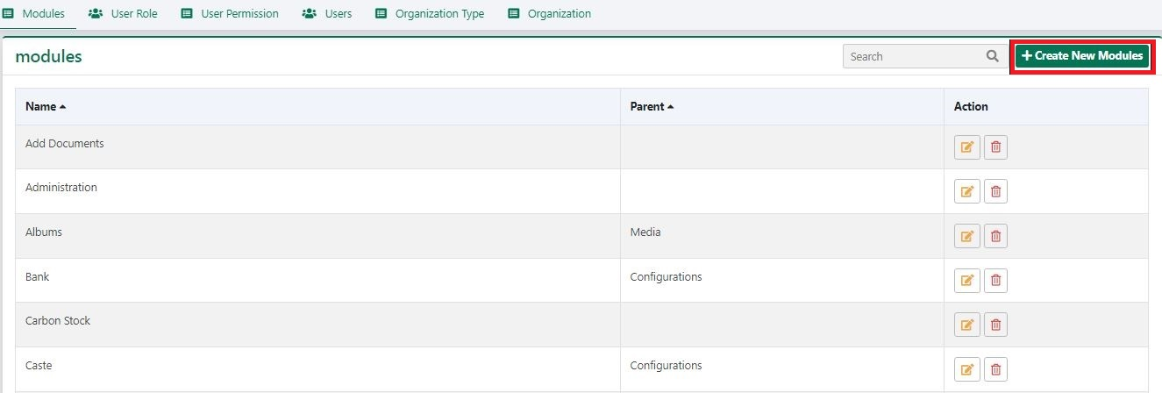
This section enable user to add, modify and delete Modules.
To add a new Modules, click on create New Modules. On doing so a form will appear in screen as shown in image below.
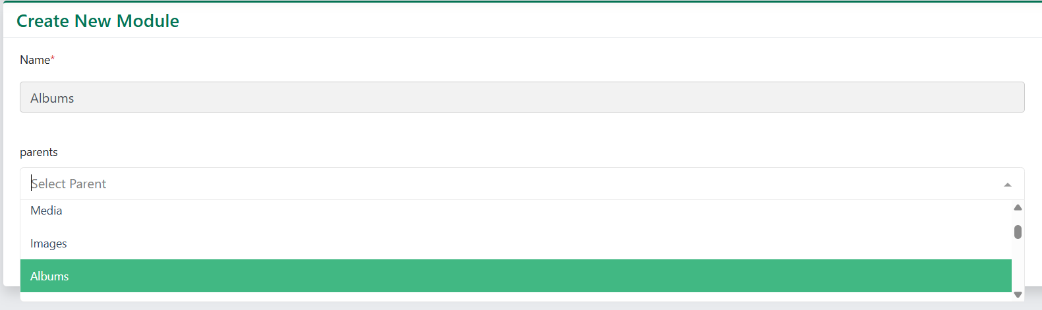
Insert the name and select the “parent” then click on submit . To modify or delete the old data, click on corresponding buttons

User Role
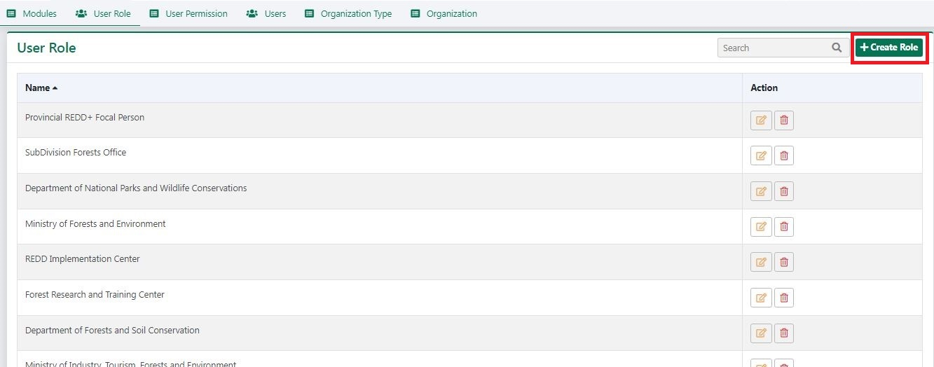
User Role are used to specify user level which will be assigned when a user is created. Later on a permission is assigned to these role according to which a user will be able to use the system. Click on the User Role menu under Administration. On doing so User role page will be loaded as show in figure below:
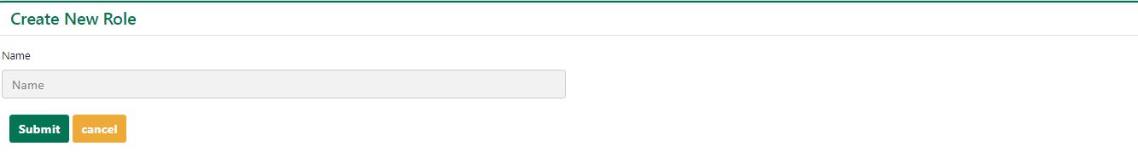
To create new Role, click on create button. On doing so a form will appear as shown in figure below. Enter the name for new role and press submit button to save the data in server.
Similarly, user can edit or delete role by simply clicking on corresponding button.

User Permission
This section enable user to assign permission to different user role. Following are the steps to assign permission to a role:
Select a role from provide list
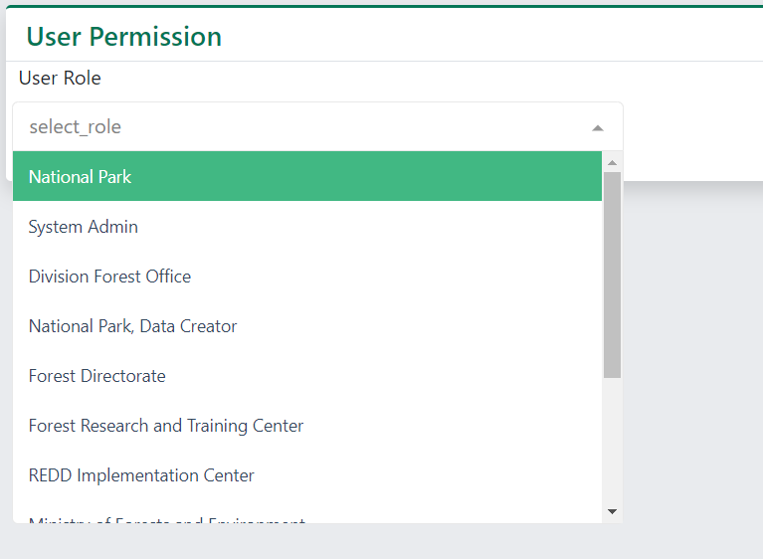
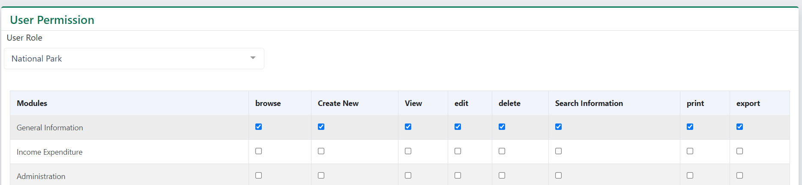
Tick a check mark on the corresponding check box

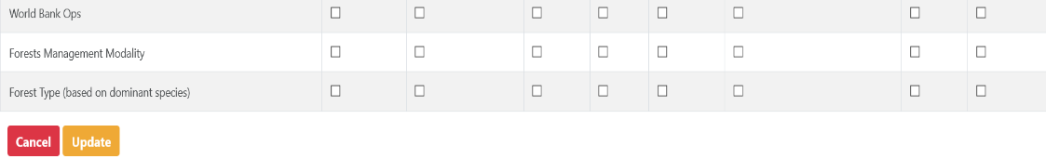
Finally, click on Update button located at the bottom of the page to save changes.

User
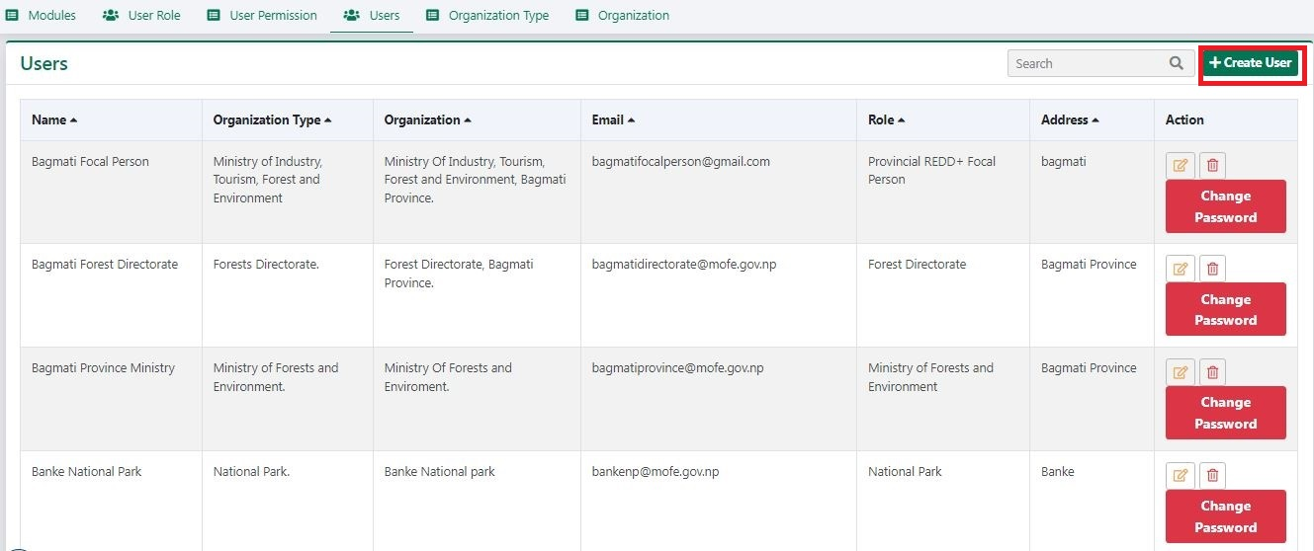
This section enable authorized user to create user account for the system. This users will be able to login into the system and access modules according to their role.
To create new user, click on create user button. A form will appear in the screen.

At first select the role.
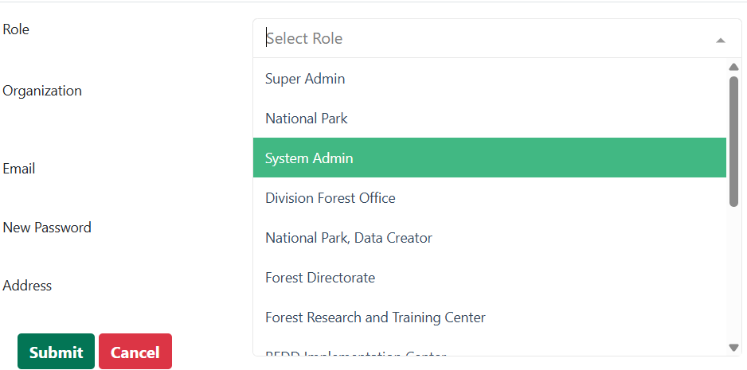
Then select the Organization Type.
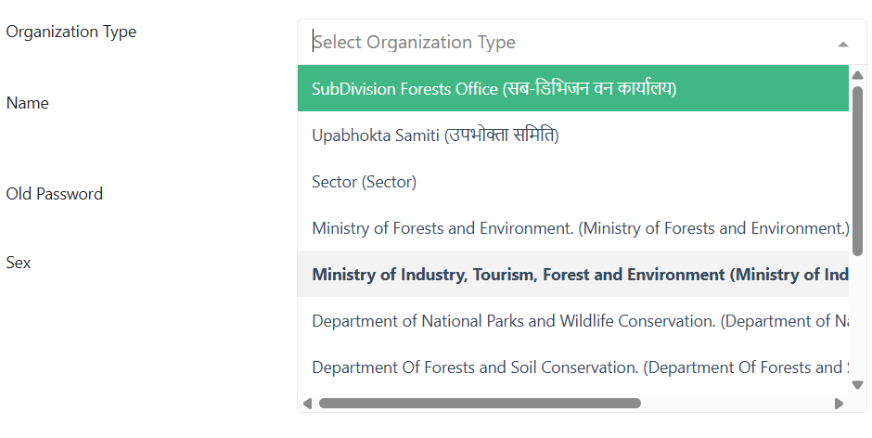
Similarly, select the Organization.
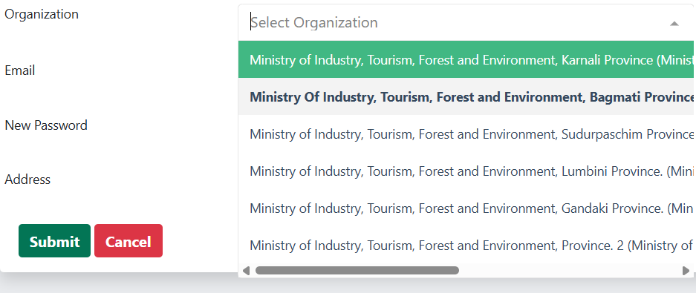
Finally, fill in other details of the form as in the picture below and click on submit button.
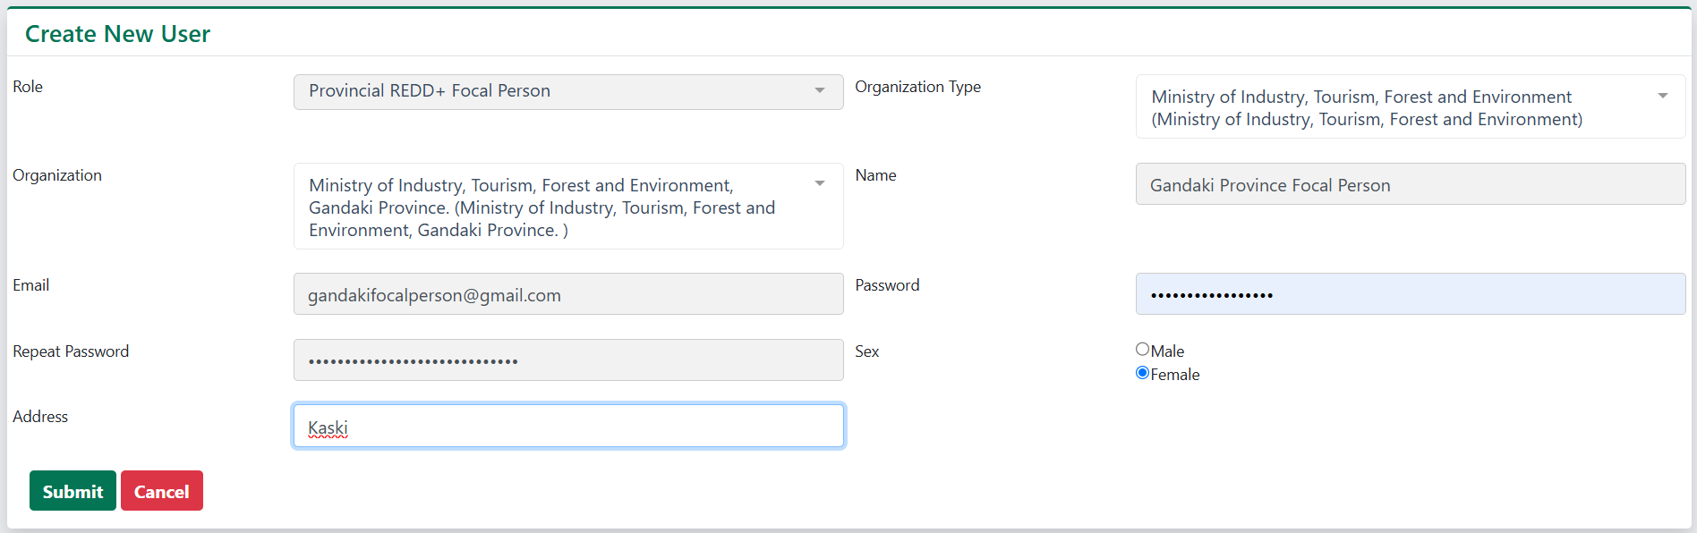
User can also edit, delete or change password of the user according to the permission they possess.

Organization Type
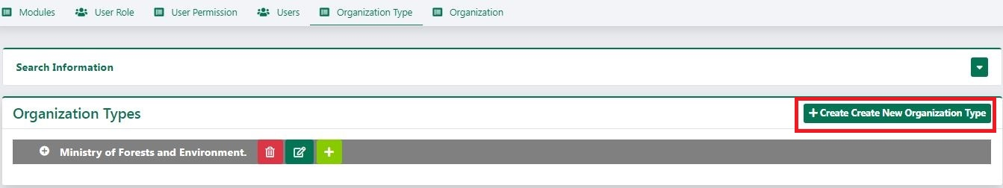
Organization types are the top level categories under which an organization belongs to. Organization type is used to classify the organization. This section enable user to add, delete or modify organization types.
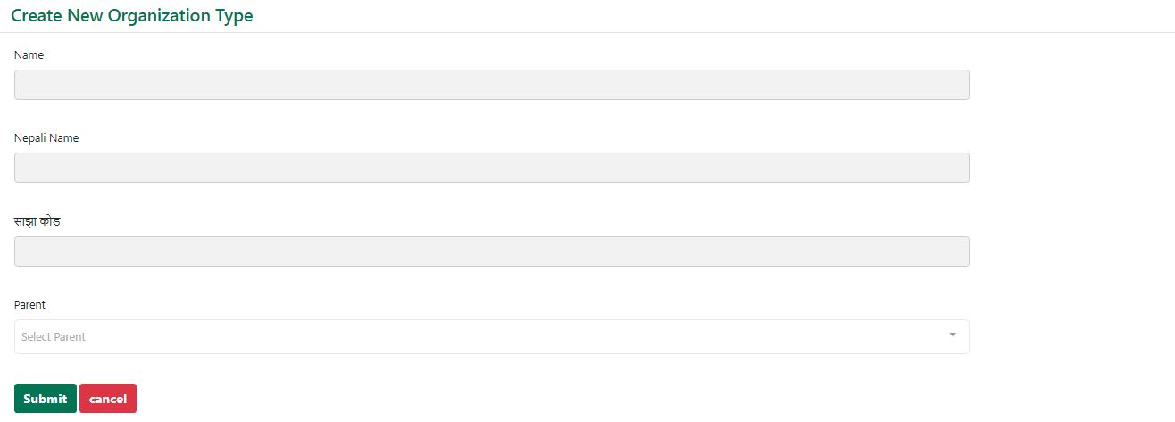
To add new organization, user can either click create button or add button. On doing so, a form will appear in screen as shown in figure below. Fill the necessary information and submit the form to save the Organization type.

Organization
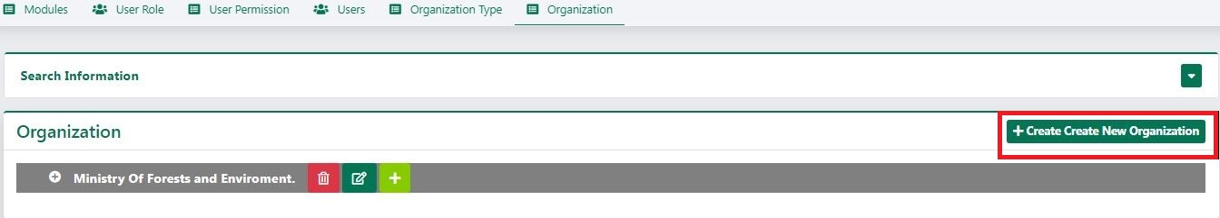
This section enables user to add, delete or modify organization.

To add new organization, user can either click on create button or on add button. On doing so a form will appear in the screen as shown in figure below. Fill the necessary information and submit the form to save organization.

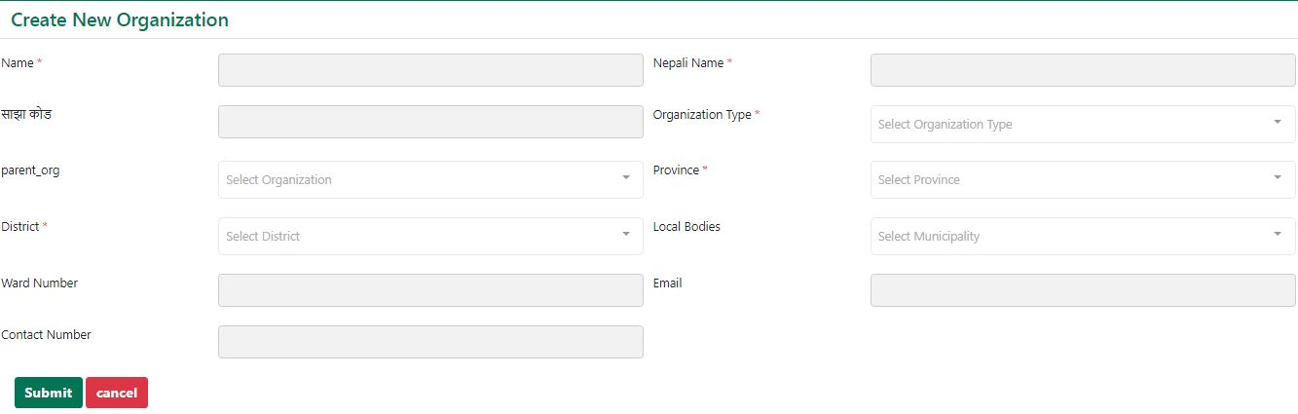

SIS Related
This section allows user to manage content that is shown in SIS website such as Pages, Categories, Images, Albums, Feedback, Document Type and Document Contact Us. Since both SIS and NFIS has same backend system, this section consist the content of both system. These contents are differentiated by the system name that user selects while logging in.

Categories
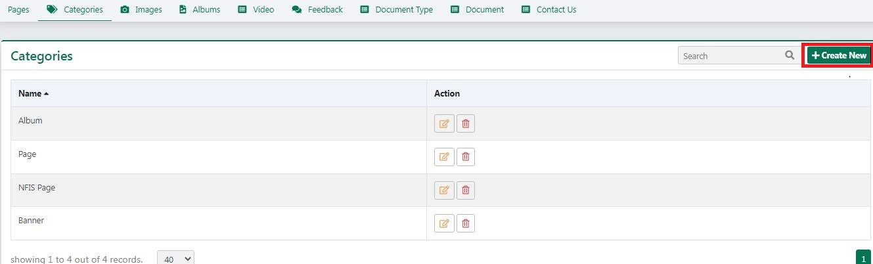
This section enables user to add, modify and remove categories.

To add new category, click on the create button. Select the module, enter the name of the module and click on submit
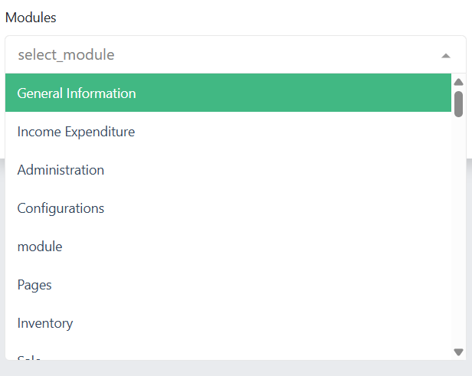

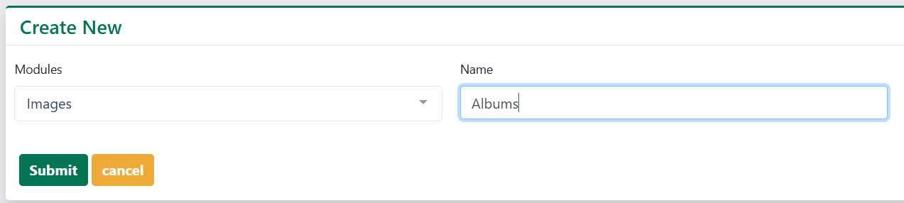

Pages
This section enables user to add, modify or delete pages.
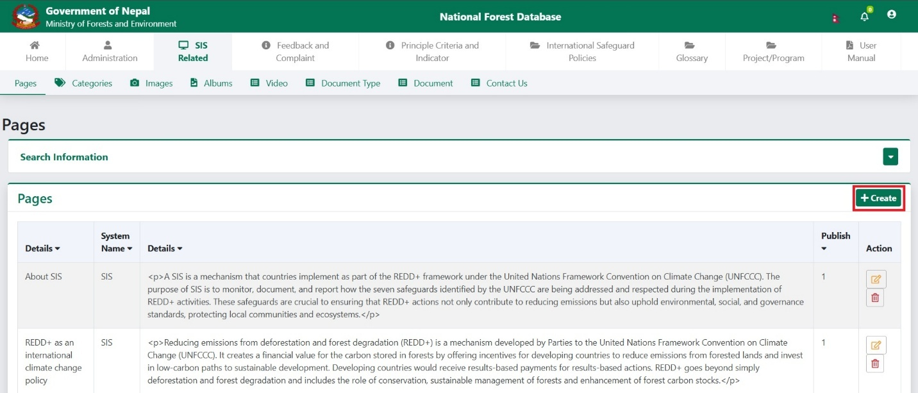
To add new page, user can click on create button. On doing so a form will appear in the screen as shown in figure below.
At first select the category.
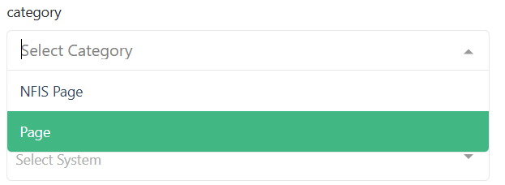
Then choose the system where you want to show the page information.
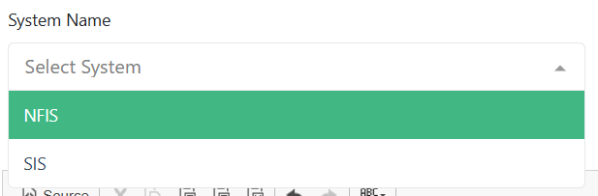
Now, fill other details of the form and click on submit.
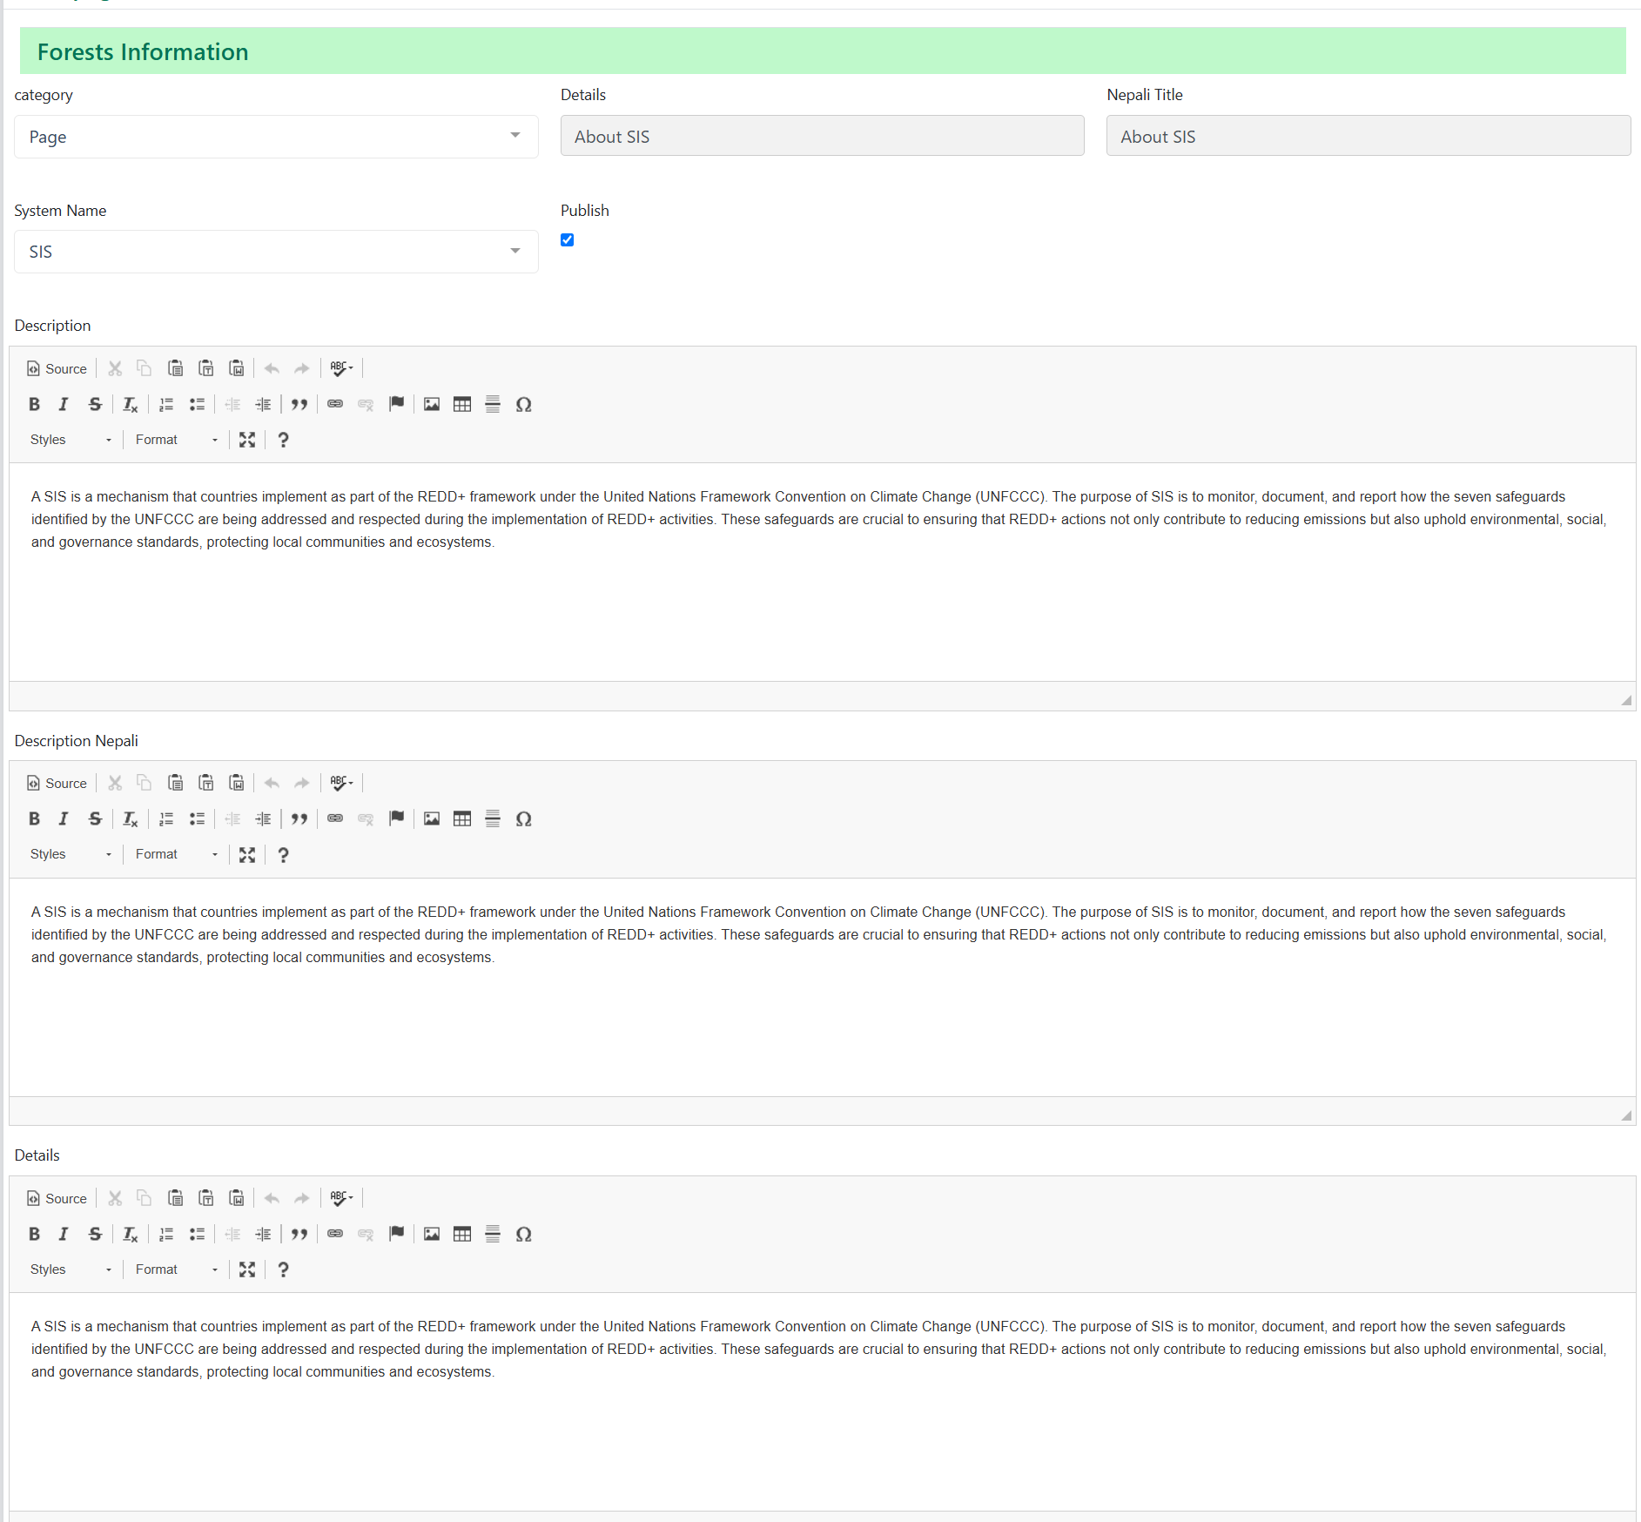
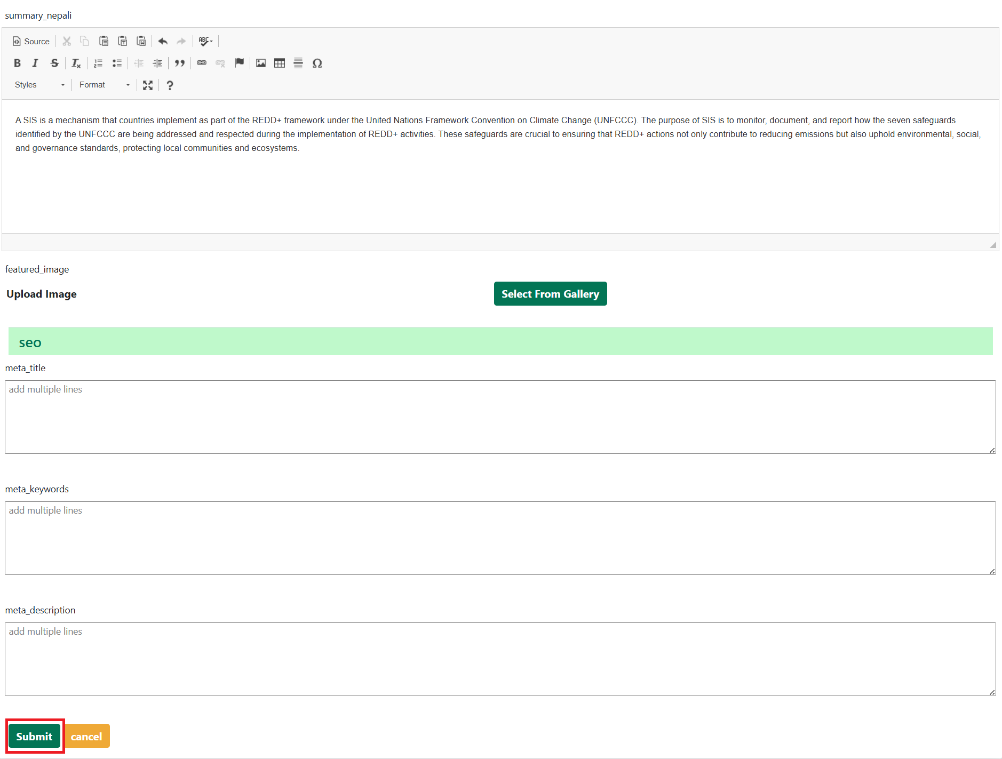

Images
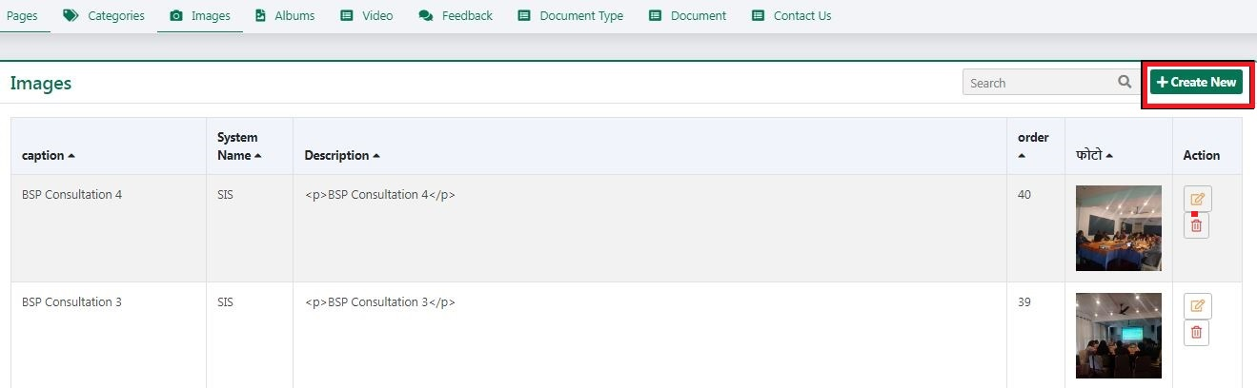
This section enables user to upload images for public system. These image will be used to create albums later on.

To add a new image, user can click in create button. On doing so a form will appear in the screen as shown in figure below. Fill the necessary information and submit the form to save image.
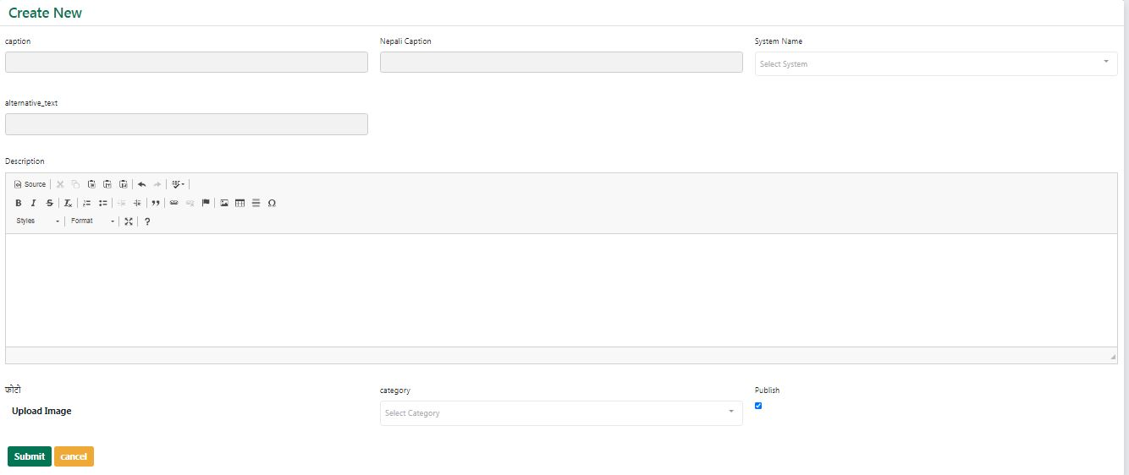

Albums
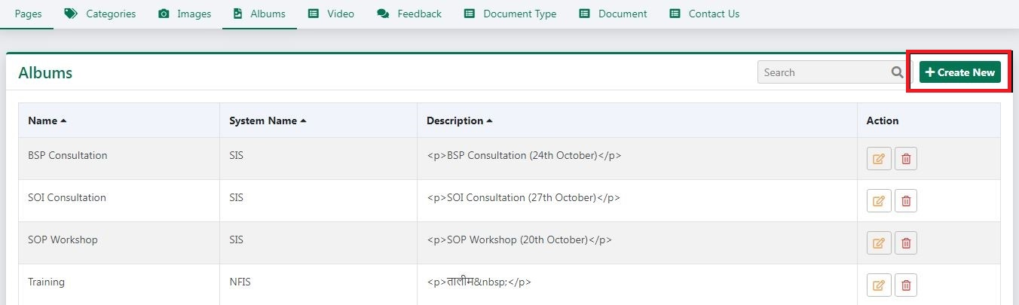
This section enables user to create albums for the website. These album will be displayed in gallery section of the system

To add new album, click on create button. On doing so a form will appear in the screen as shown in figure below. Fill all the necessary information and submit the form to save album.
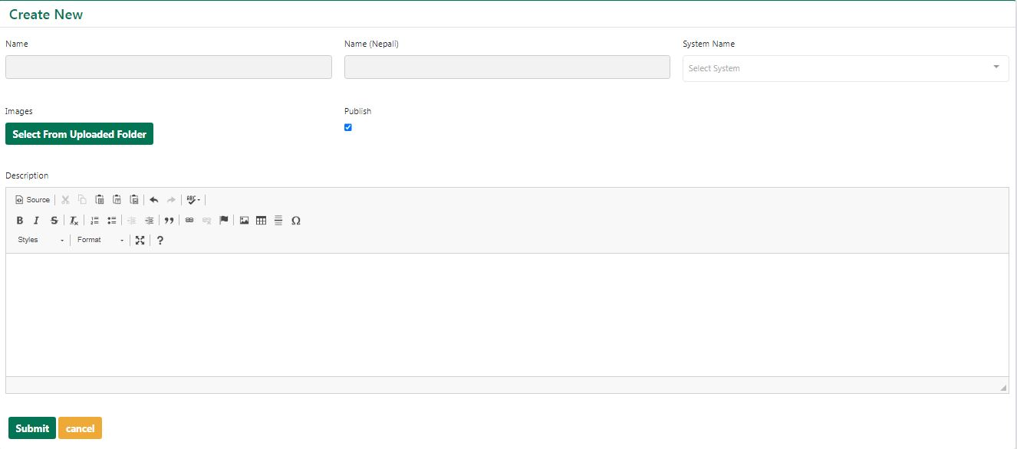

Documents Type
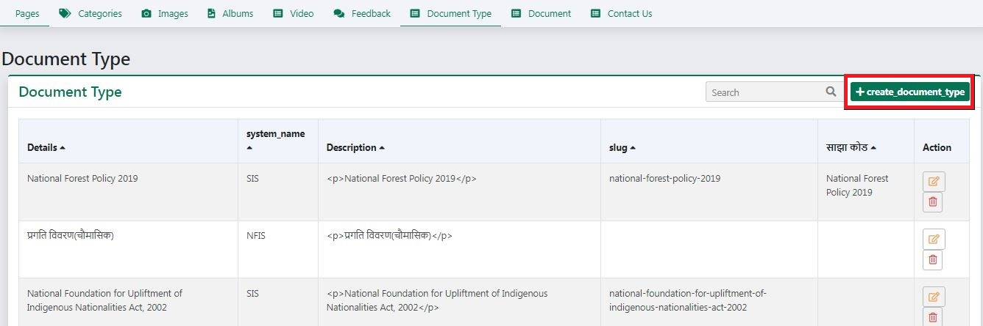
This section enable user to add, modify and delete Documents Type.
To add new Document Type, click on create button of respective modules. A form will appear in the screen.
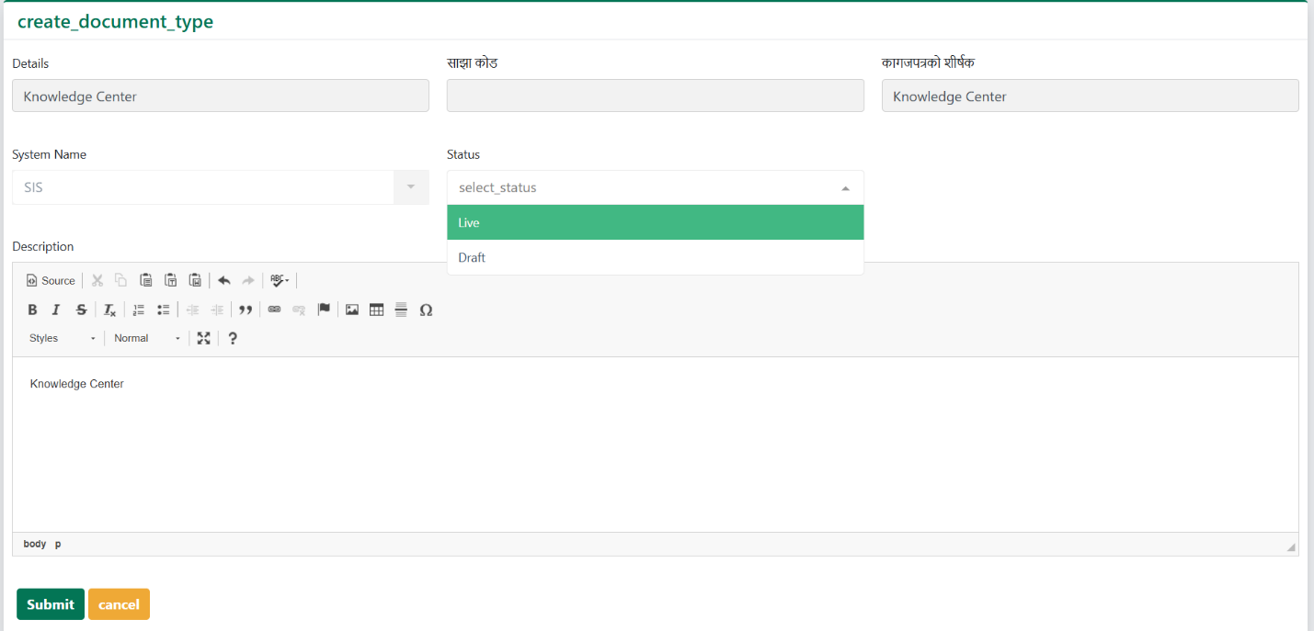

Documents
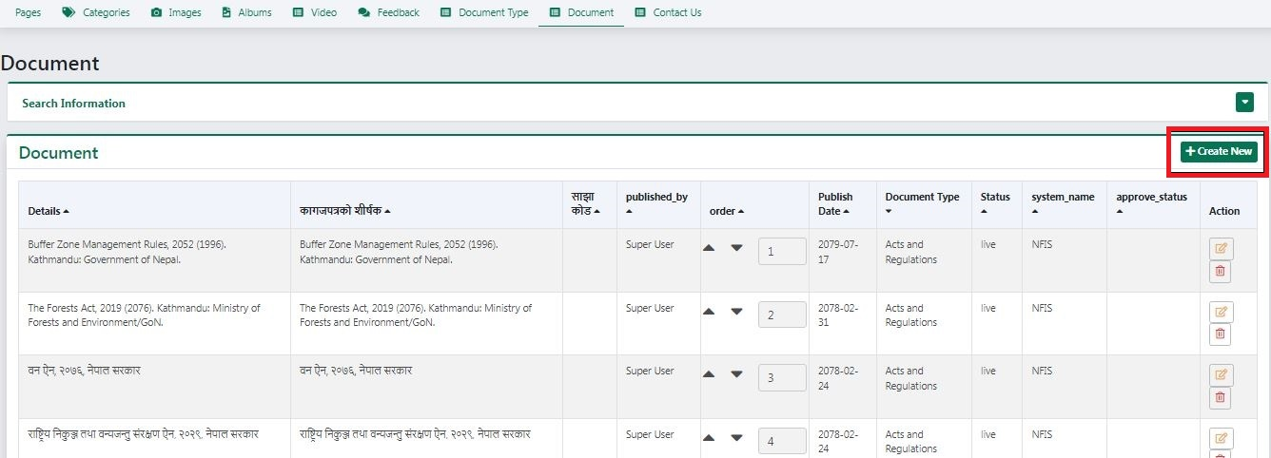
This section enable user to add, modify and delete Documents.
New documents are added by DFO users then accepted/ approved by Provincial REDD+ Focal Person. To add new Document, click on create button of respective modules. A form will appear in the screen. Firstly, select the Source of document (Custom or Link).
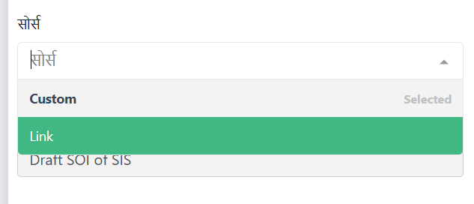
Then select the type of document to be uploaded.
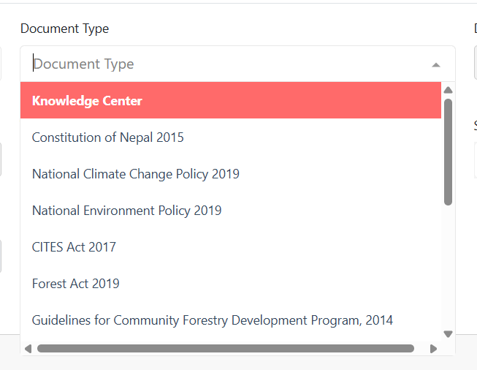
After that, fill all the necessary information’s such as Details, titles along with description, document and images then submit the form to save the information.
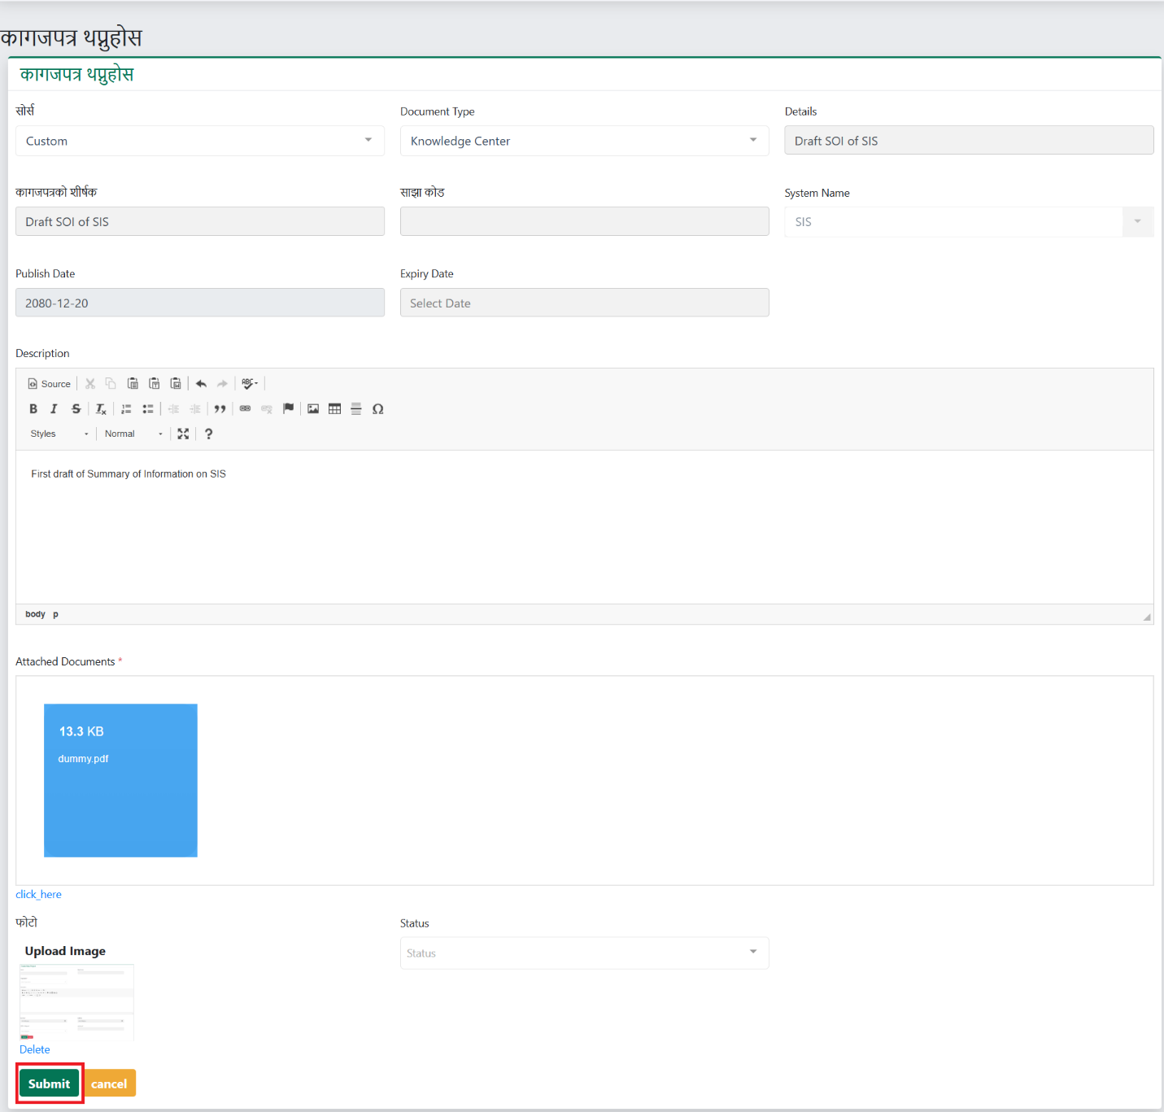
After the document is created, it is shown in the index page along with the status of the document as shown below.
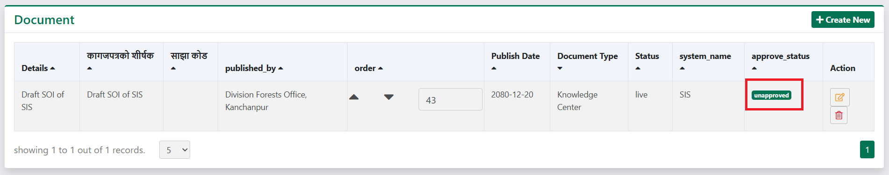

This same document is shown in Provincial REDD+ Focal Person’s Document section.
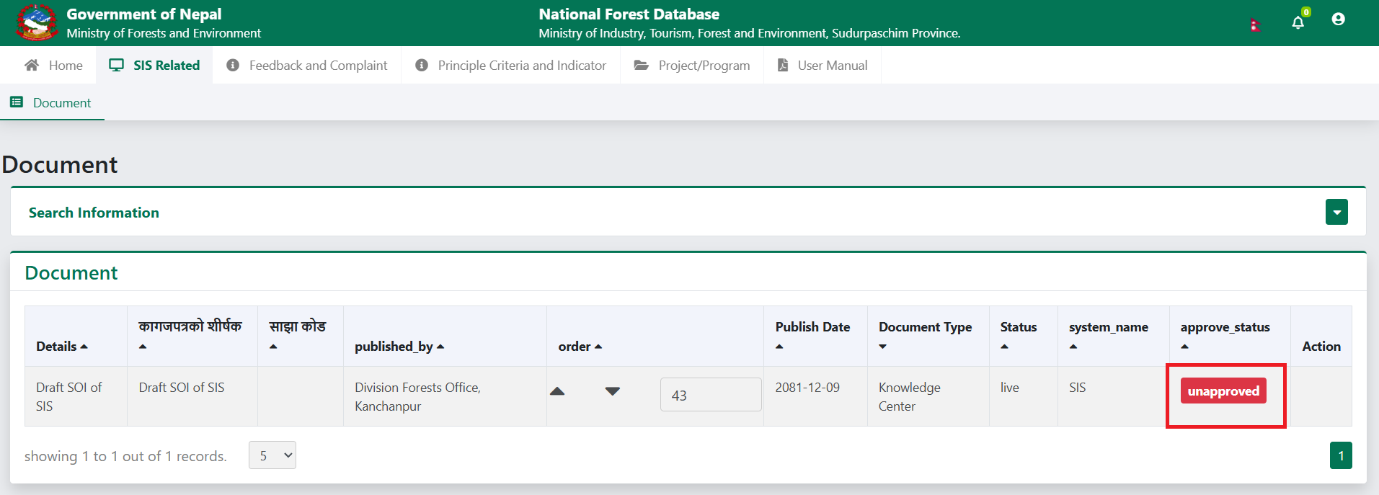
On clicking on “unapproved”, system asks the user if they want to change the status of document to “approved” on clicking yes, the status changes and is published in the front end of system.
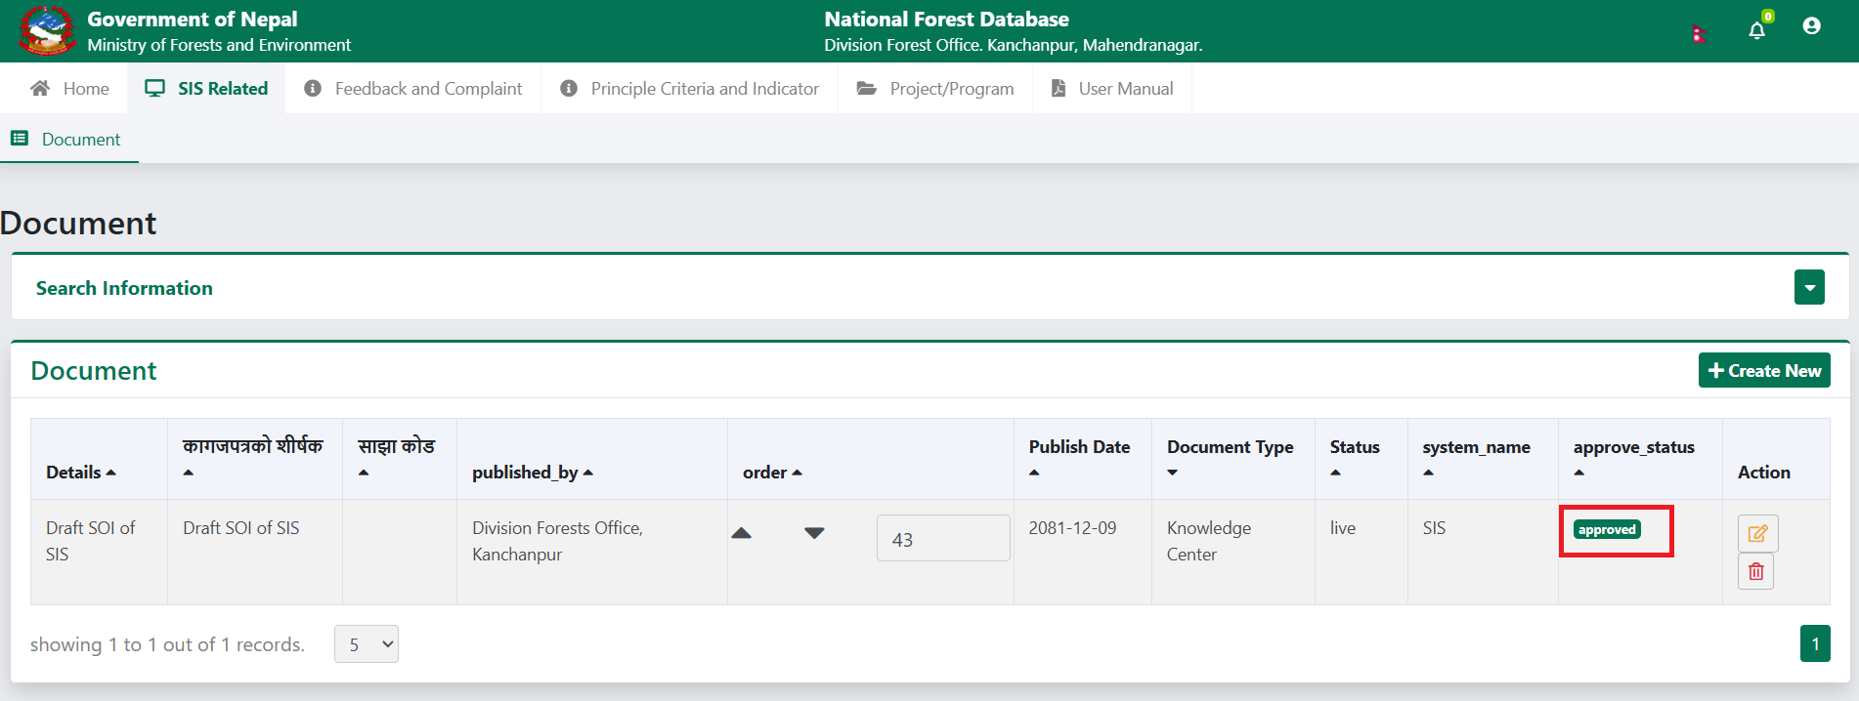

Feedback and Complaint Management
This section allows authorized user to manage content of Feedback/Grievance in SIS module such as Complaint/Grievance Type, Complaint/Grievance as show in image below:
These modules are accessible to admin user. Focal person user has the access of only of Project and Verifier module. Following are the procedure to manage data on these modules:

Complaint/Grievance Type
This section enables user to manage the grievance type records. Grievance types are the types of complaint that a user can file in SIS system.
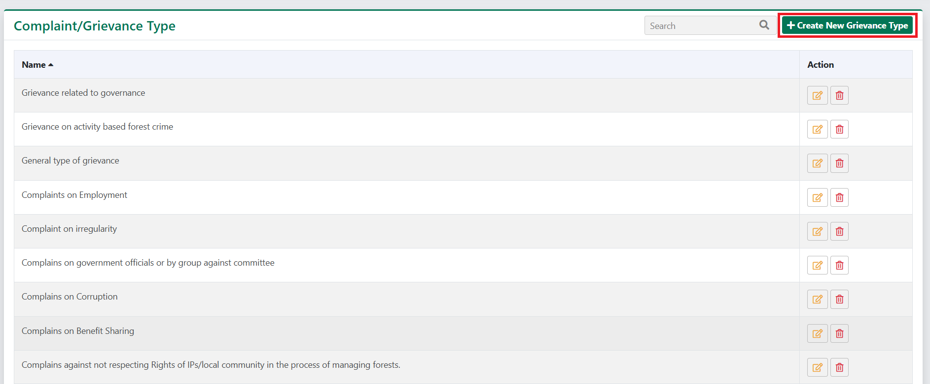
To add a new grievance type, click on create button. On doing so a form will appear in screen as shown in image below. Enter the type of grievance and click on the submit button to save the data. To modify or delete the old data, click on corresponding edit () and delete () buttons.
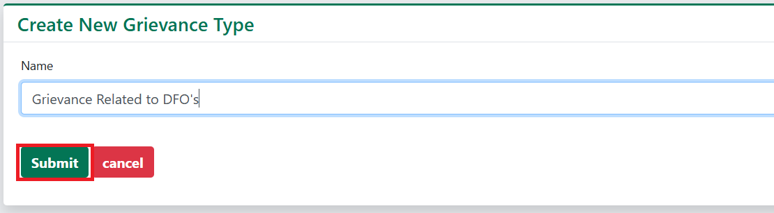

Complaint/Grievance
This section enables admin user to manage the grievance submitted by the general public through public system or admin users can also register grievances received by other methods like phone calls, mails, letters, whatsapp etc.
In the system, the grievance handling process begins when a complaint or grievance is received from the public and is initially directed to the provincial focal person. Additionally, the provincial focal person has the ability to create grievances that are received through other channels such as email, WhatsApp, letters, and more.
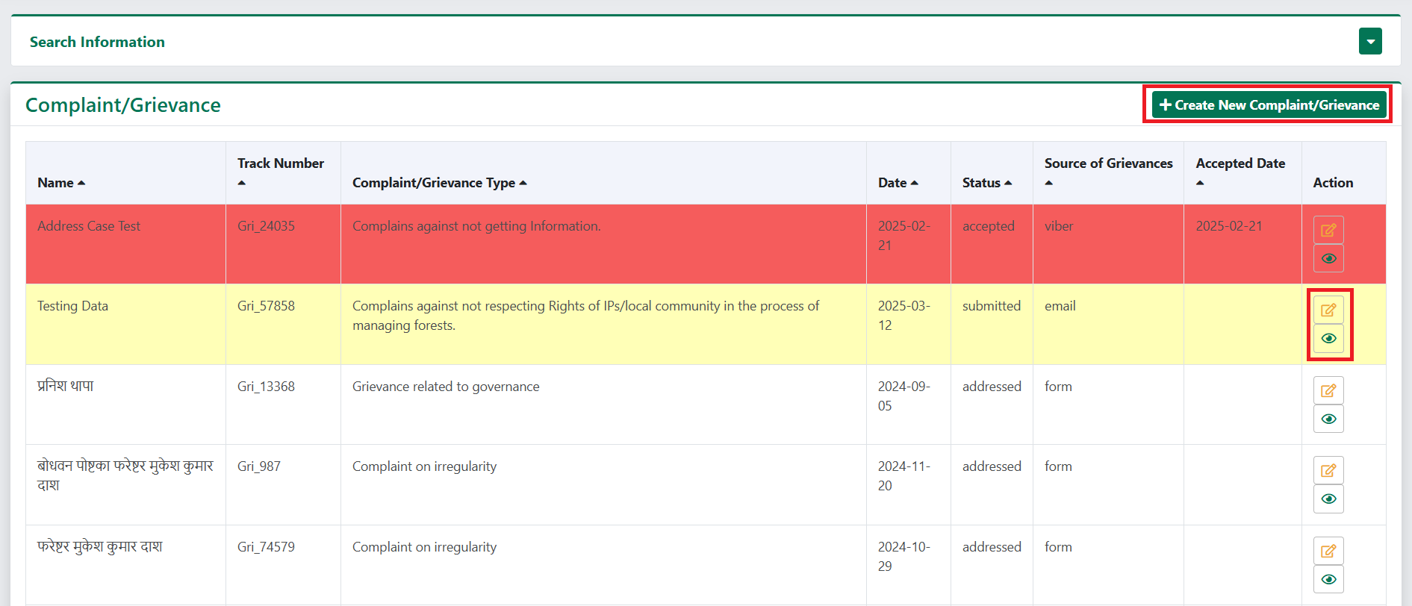
To add a new grievance, click on create button. On doing so a form will appear in screen as shown in image below.
Select the complaint type
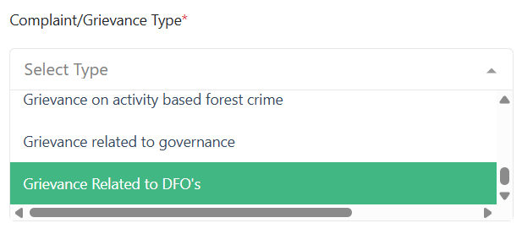

Enter the name and date then select the province, district and the local bodies
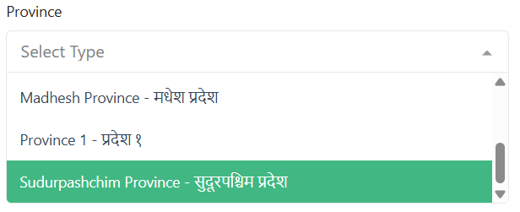 | 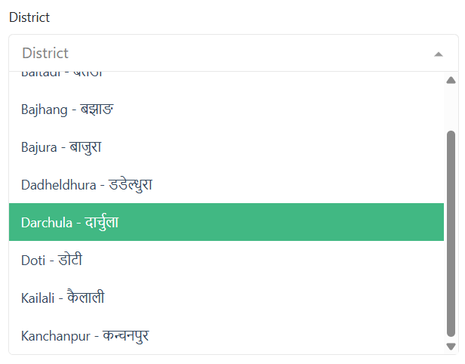 | 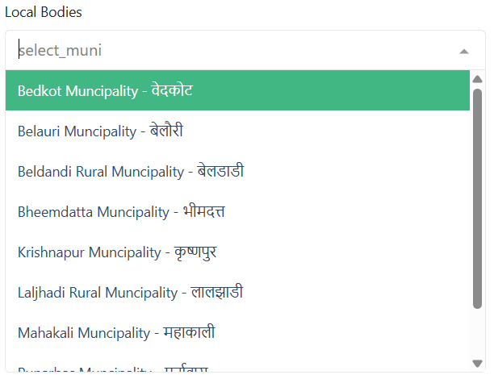
Enter ward number, tole, email, contact number and link if mentioned. Then select how you want the complaint to be shown i.e. private or public
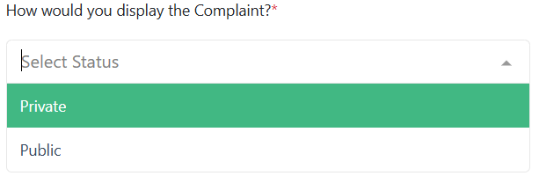
Now, select the source of complaint/grievance received. Also enter the description and document if available.
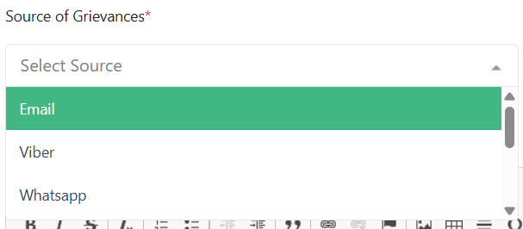

Finally, whole filled up form will look like as shown in the picture below.
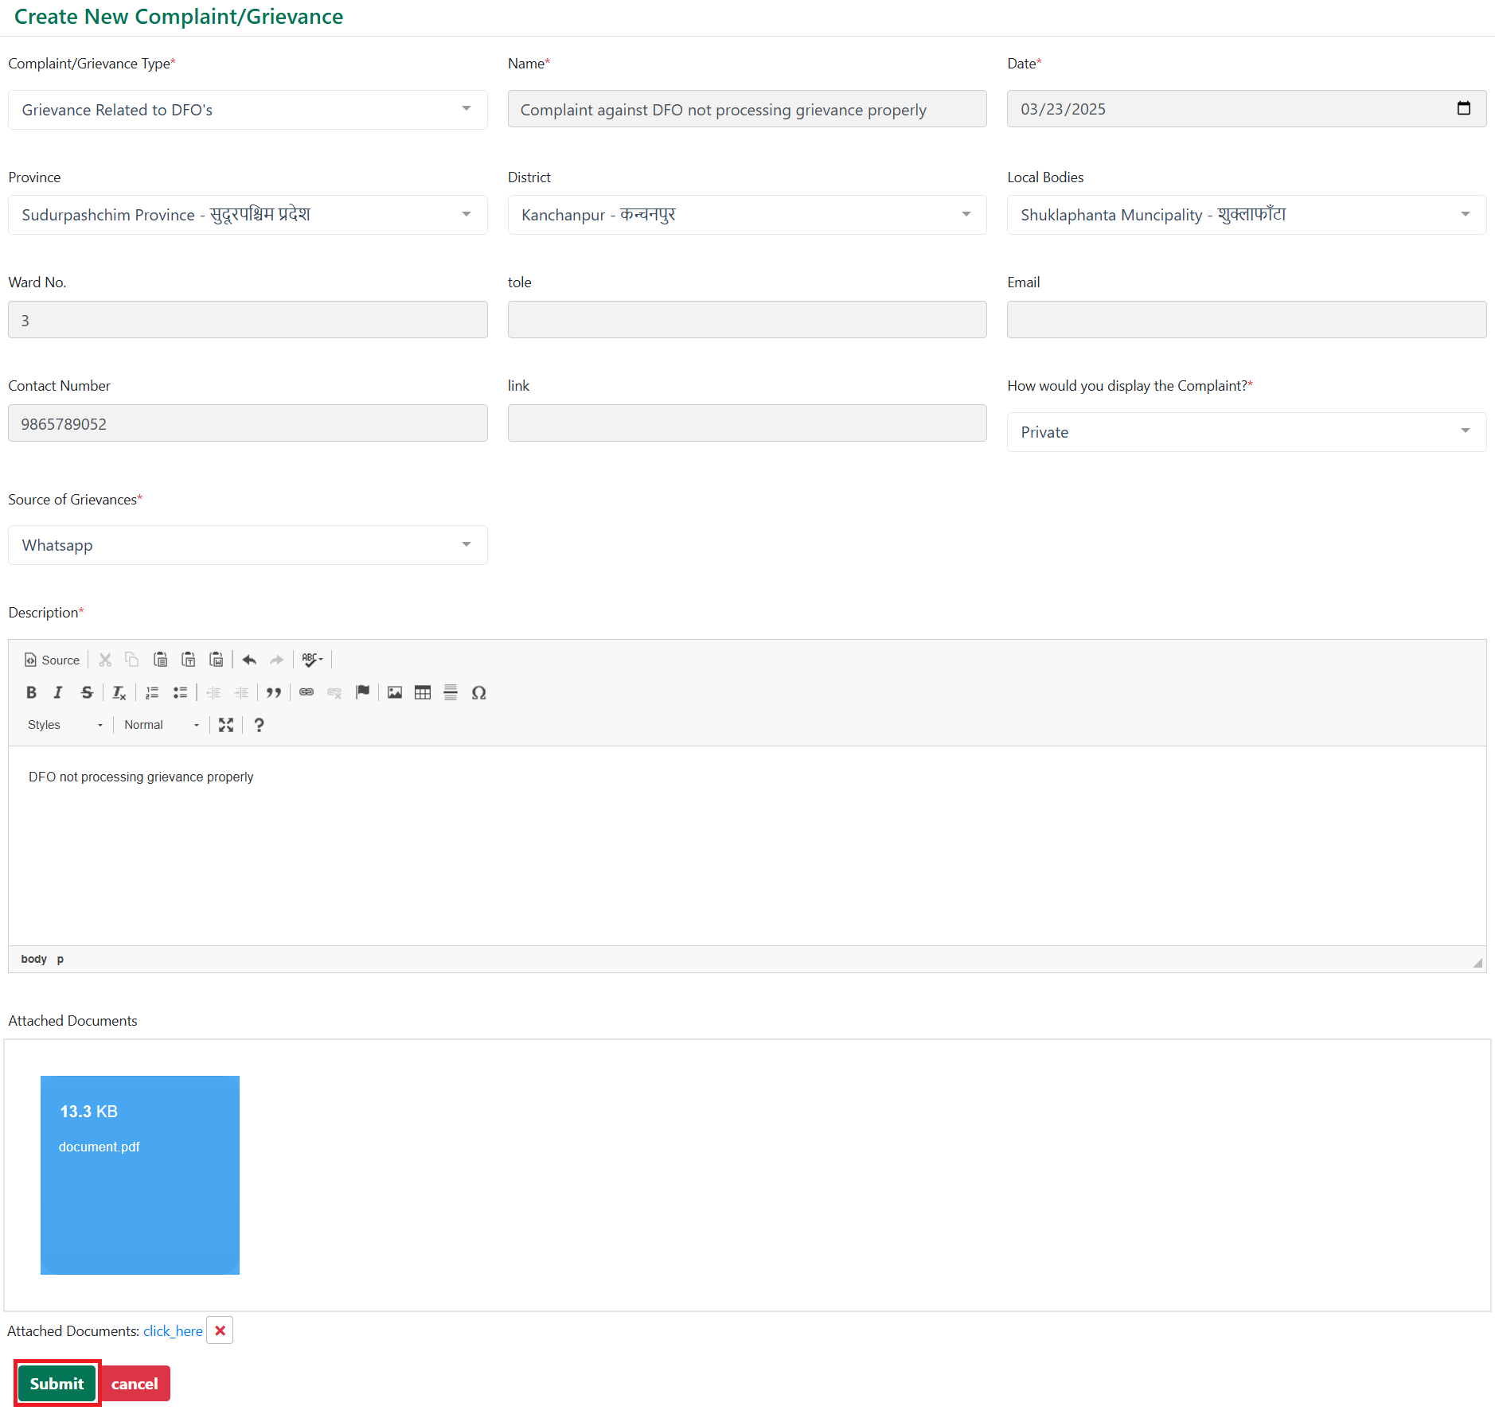

Complaint/Grievance Processing
After the submission of grievance, it is shown in provincial focal person as in the picture below
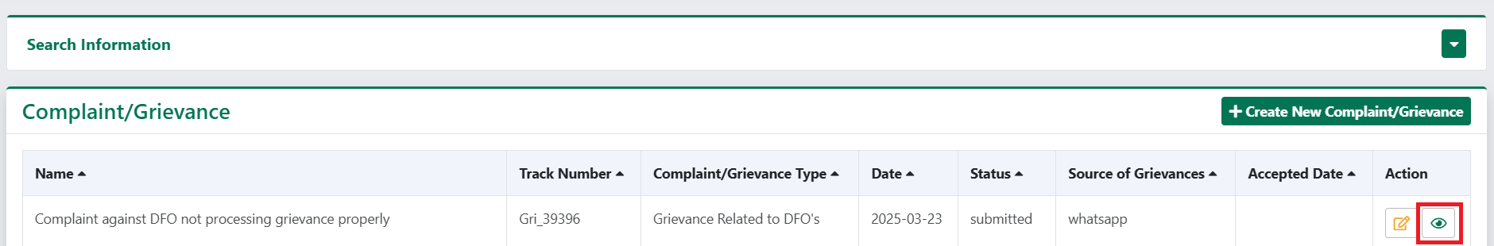
Here click on view button and choose either to accept or reject the complaint/grievance. Here, Clicking “Accept” button means that the grievance will be processed further and clicking the "Reject" button means that the grievance will not be processed further, effectively ending the grievance handling process without any resolution or approval.
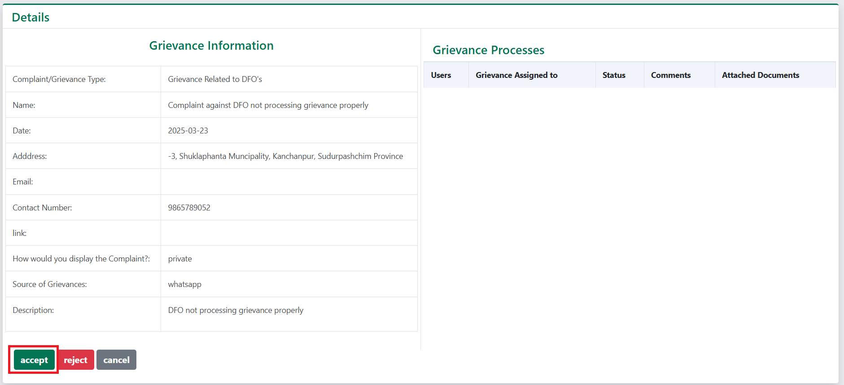
After accepting complaint/grievance, status of complaint changed to accepted. Here, click on view button.
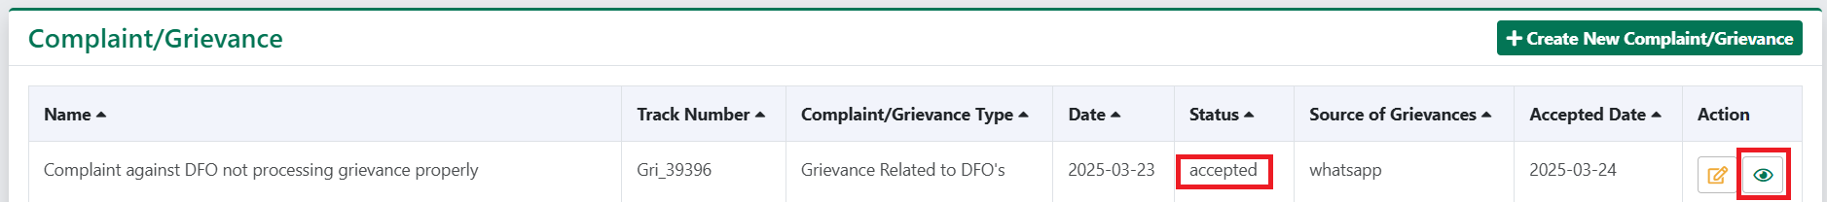
Below shown page appears after clicking the view button.
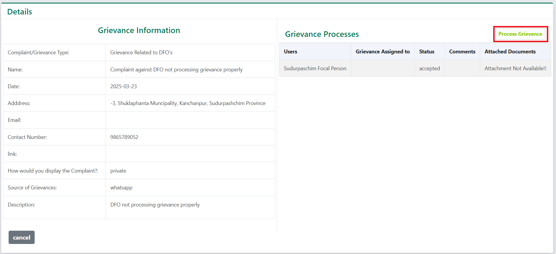
On this page, click on "Process Grievance" to open a form. In this form, if the provincial focal person can address the grievance, they select the grievance status, provide a description, upload any relevant documents, and submit the form. If the grievance cannot be handled by the provincial focal person, they assign it to another organization.
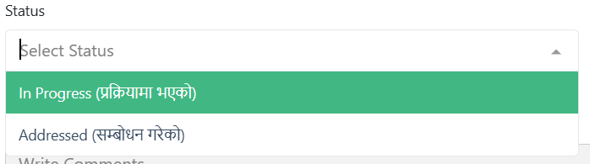
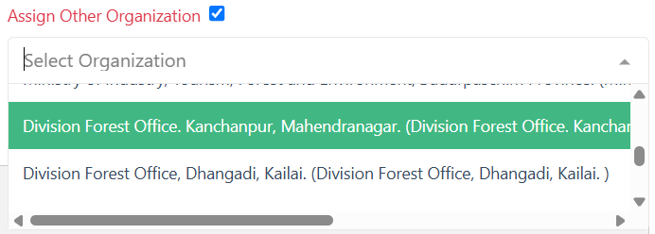
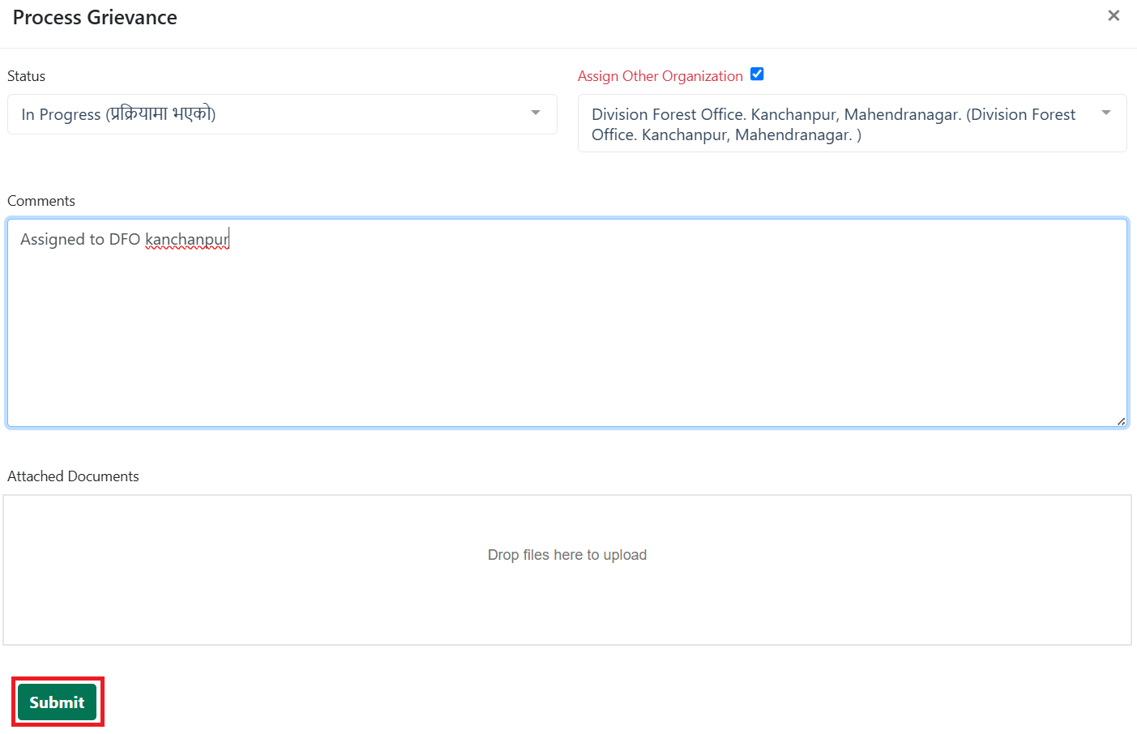

After the grievance is assigned to related organization, it is shown as below.
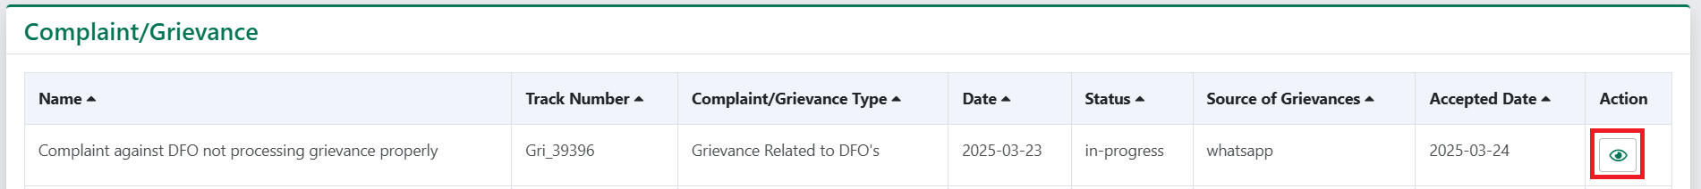
On clicking view button, another page opens up showing details of grievance and processes completed.
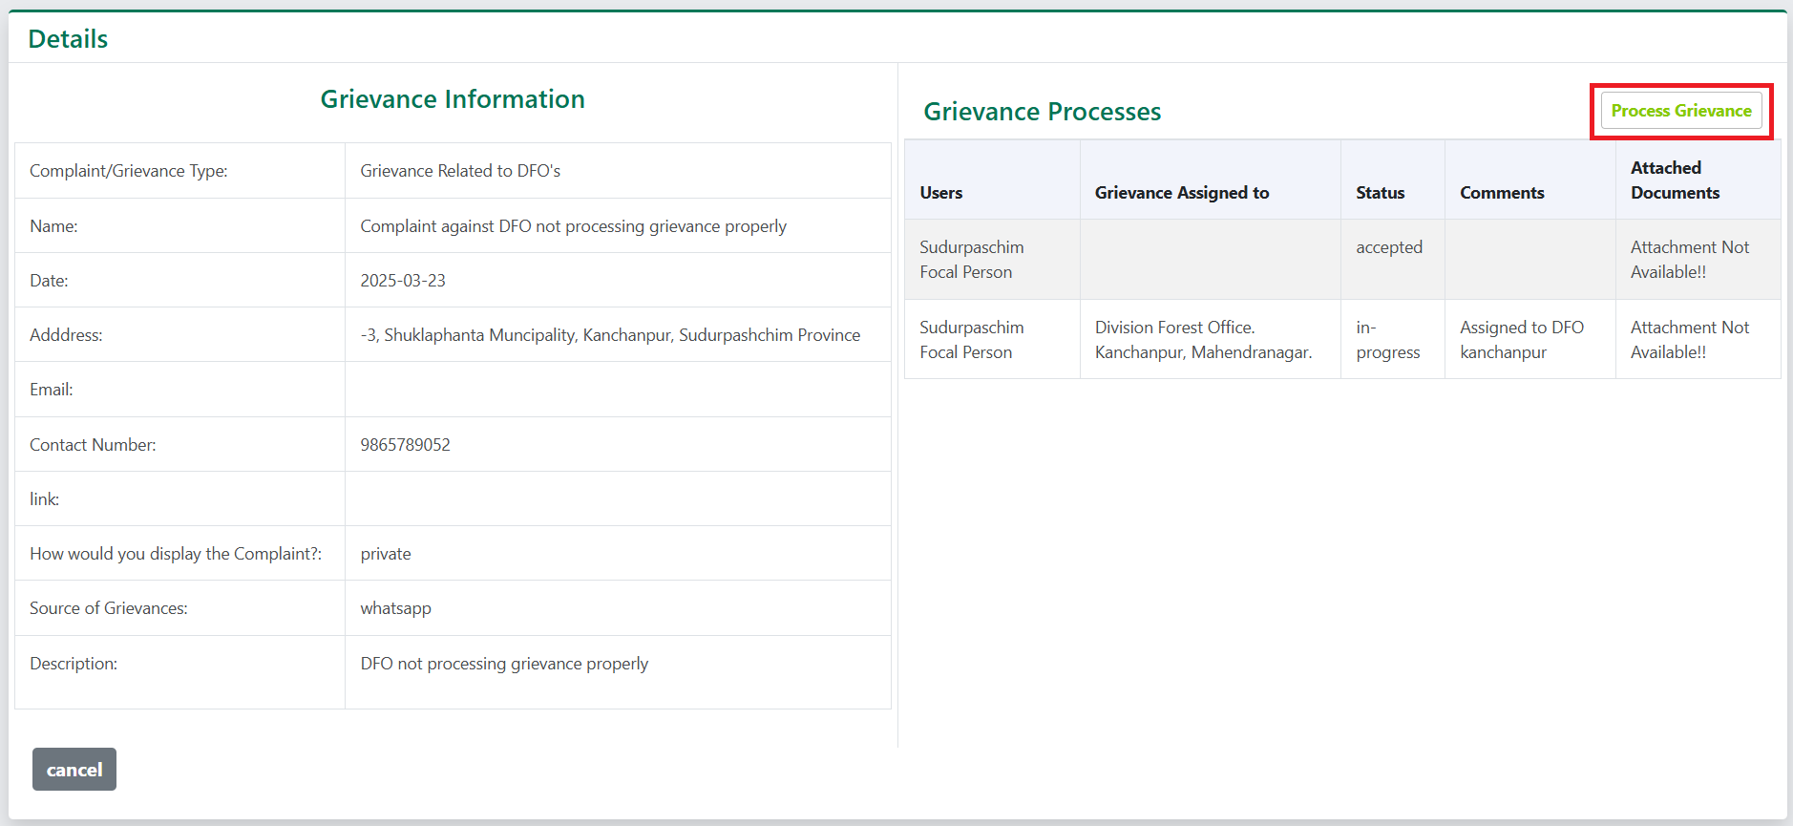
Click on "Process Grievance" as shown in the picture above. As stated earlier, once the complaint is resolved, select the status, attach any relevant documents, write comments, and submit the form. If the grievance cannot be handled by this organization, it can be forwarded to another organization by selecting "Assign to Other Organization."
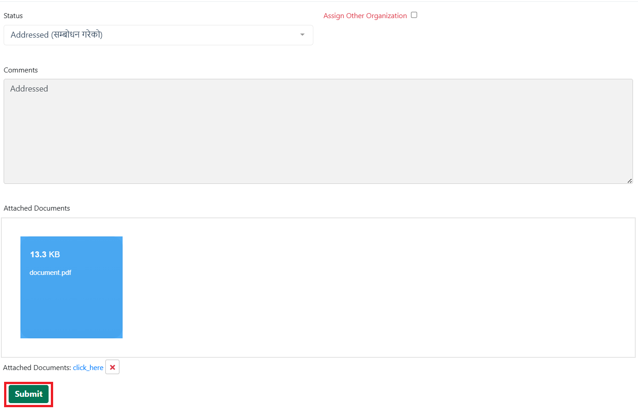

Principle Criteria and Indicator
This section enables user to add, modify and delete Nepal’s approach to safeguard record.

Principle
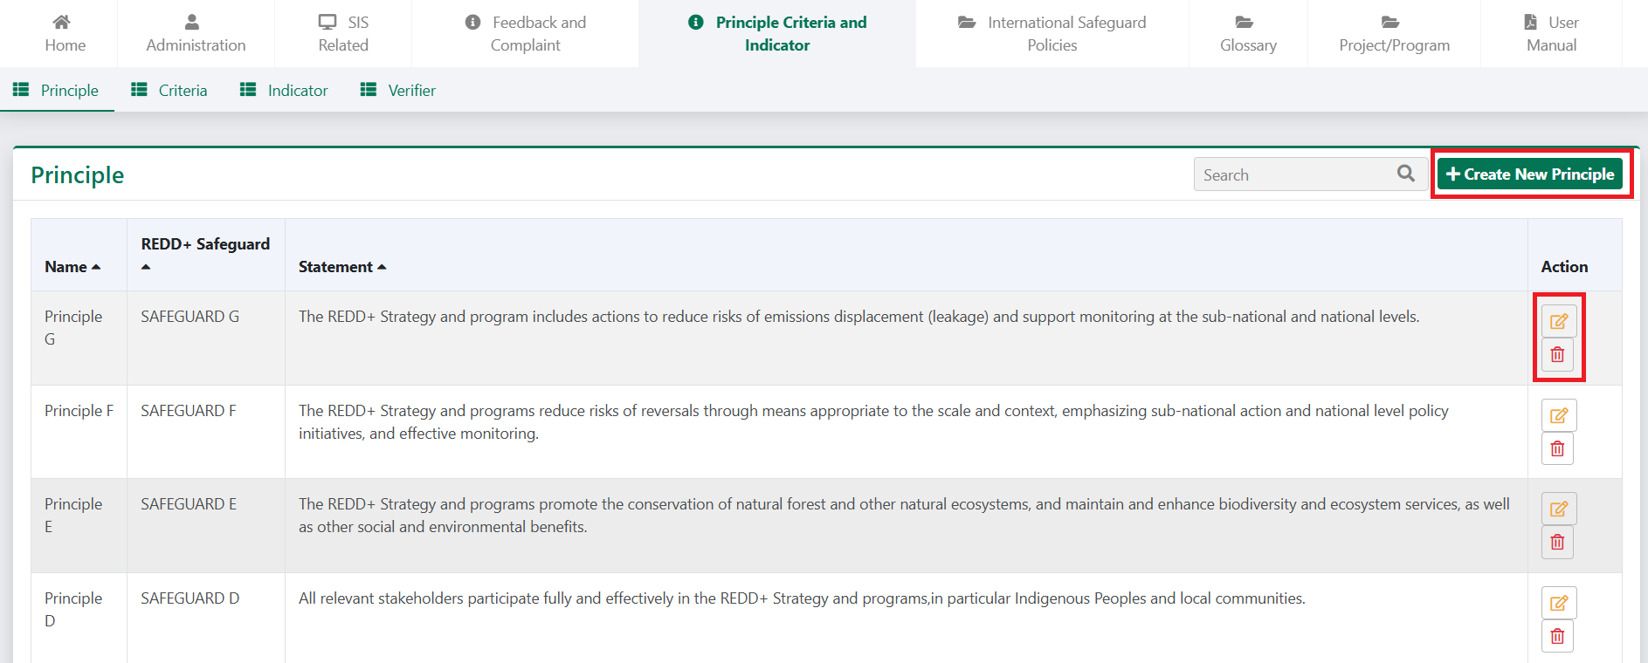
In this section, click on “create New Principle” to create new principle.

On doing so a form will appear on the screen as shown in image below. Enter the name, strategy and choose REDD+ Safeguards
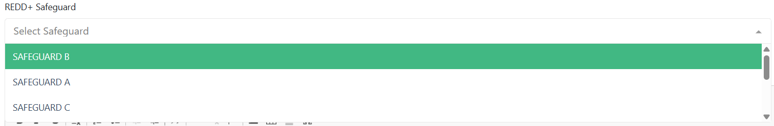
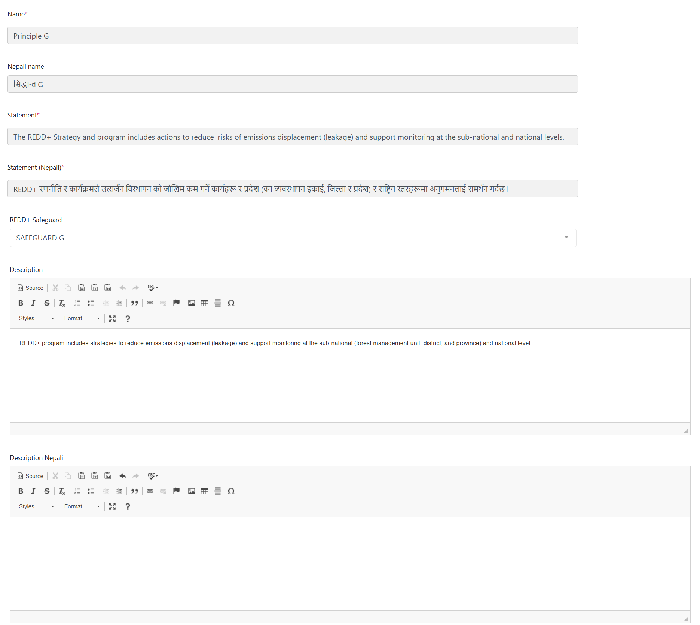
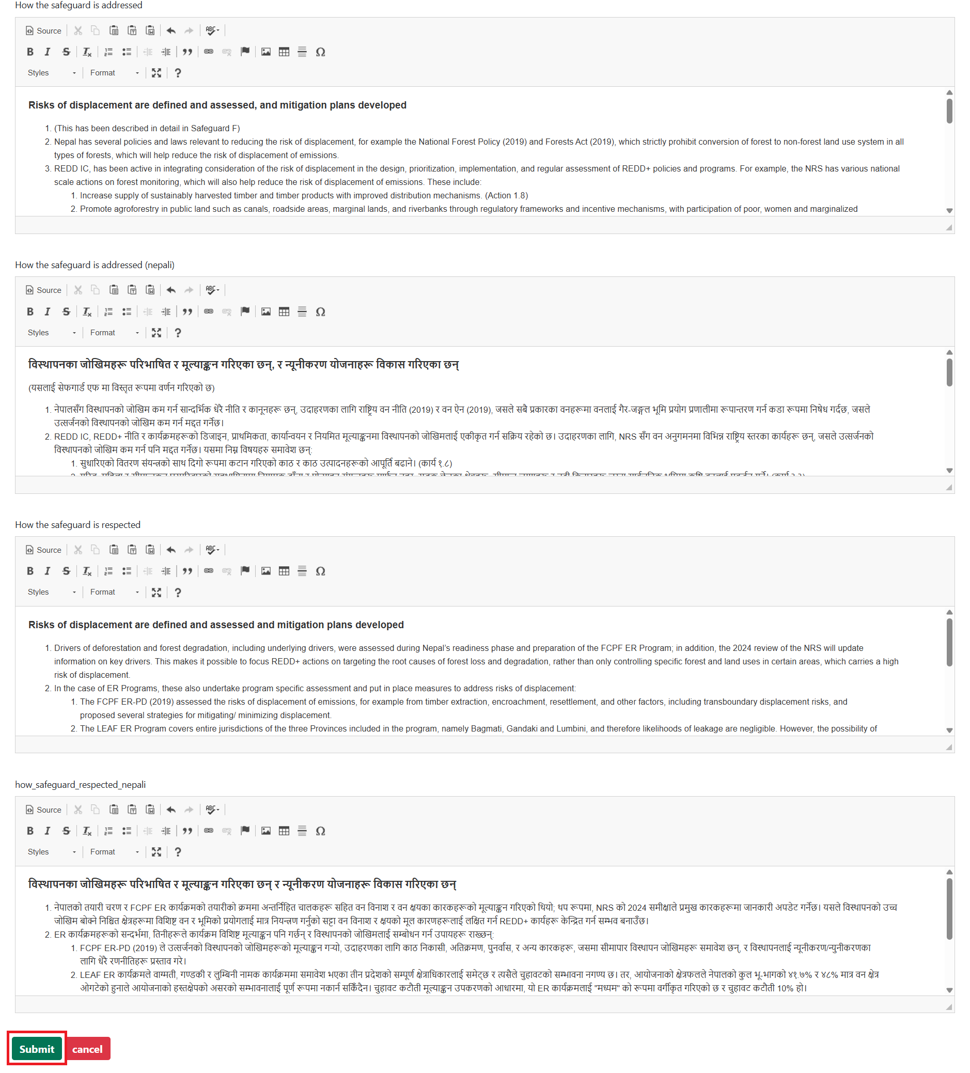
After filling up all details, click on submit.

Criteria
This section enables user to add, modify and delete Criteria.
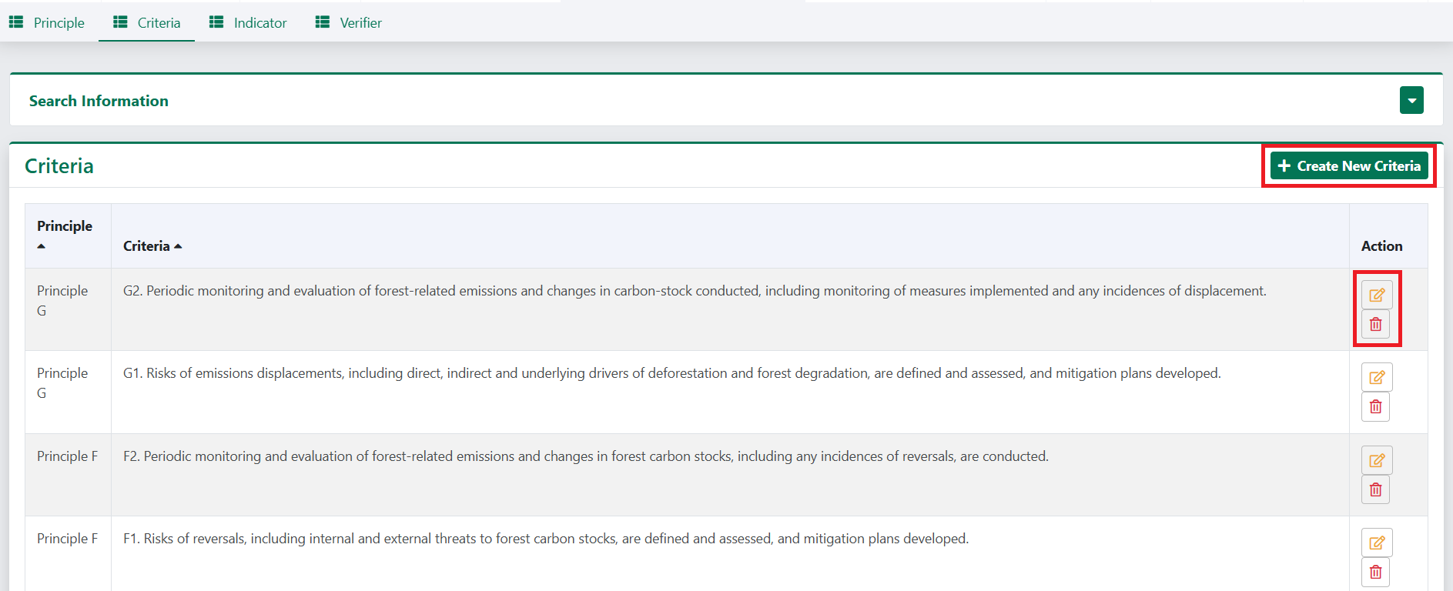
To add a new Criteria, click on create New Criteria. On doing so a form will appear in screen as shown in image below. Select the principle.
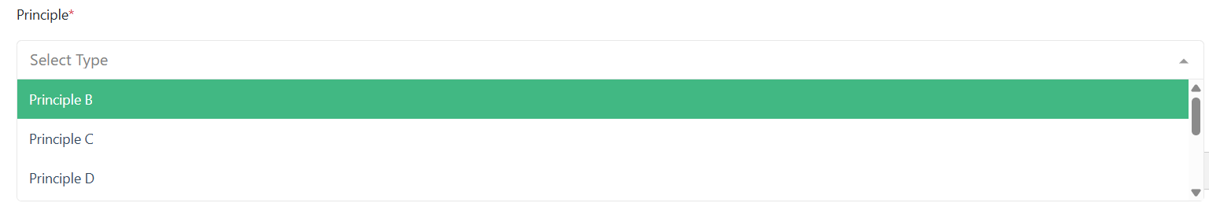
Then fill up the form as shown in the picture below.
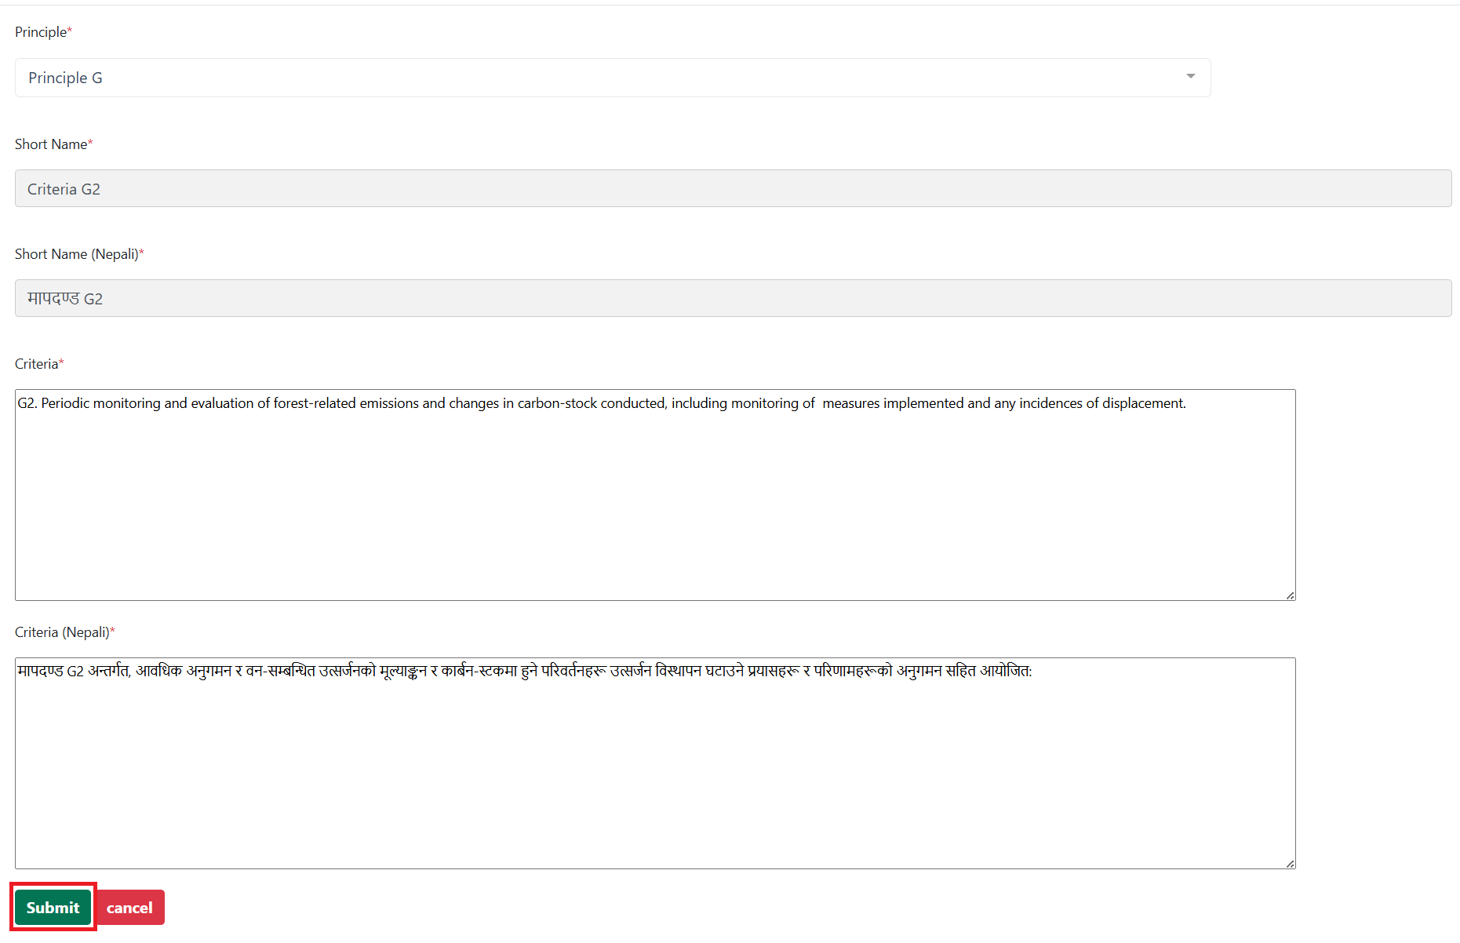
Click on submit button.

Indicator
This section enable user to add, modify and delete indicator.
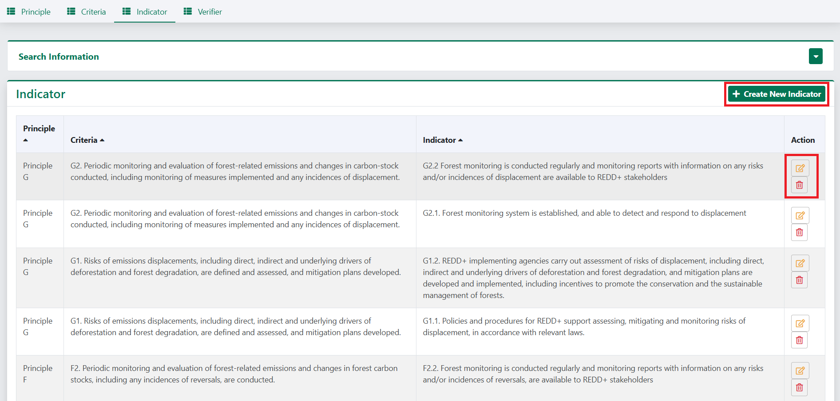
To add a new Indicator, click on create New indicator.
Select the principle and criteria then enter the indicator and click on submit button.
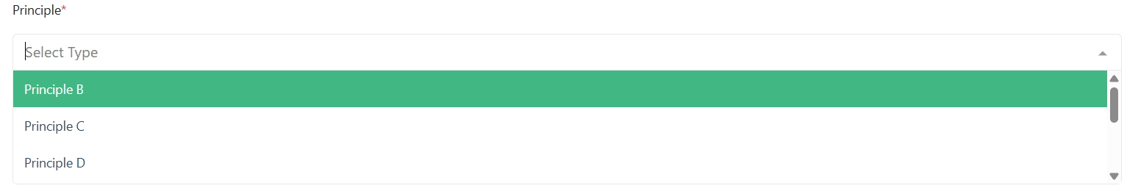
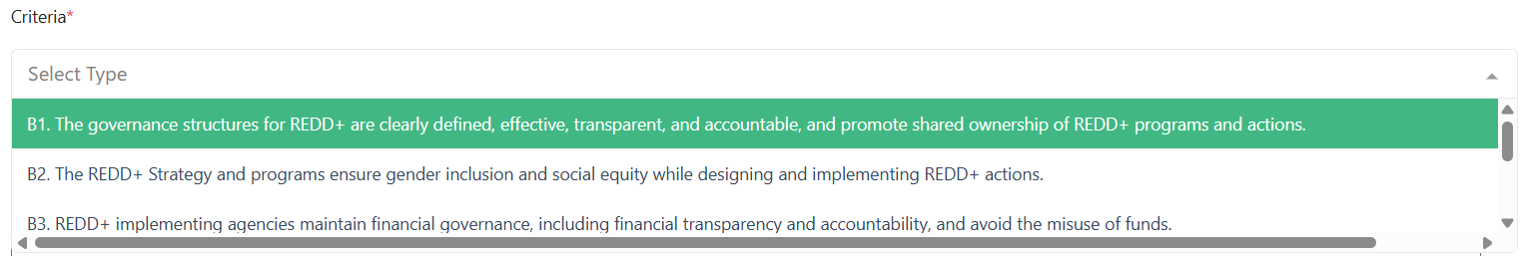
Filled up form for indicator looks as displayed below.
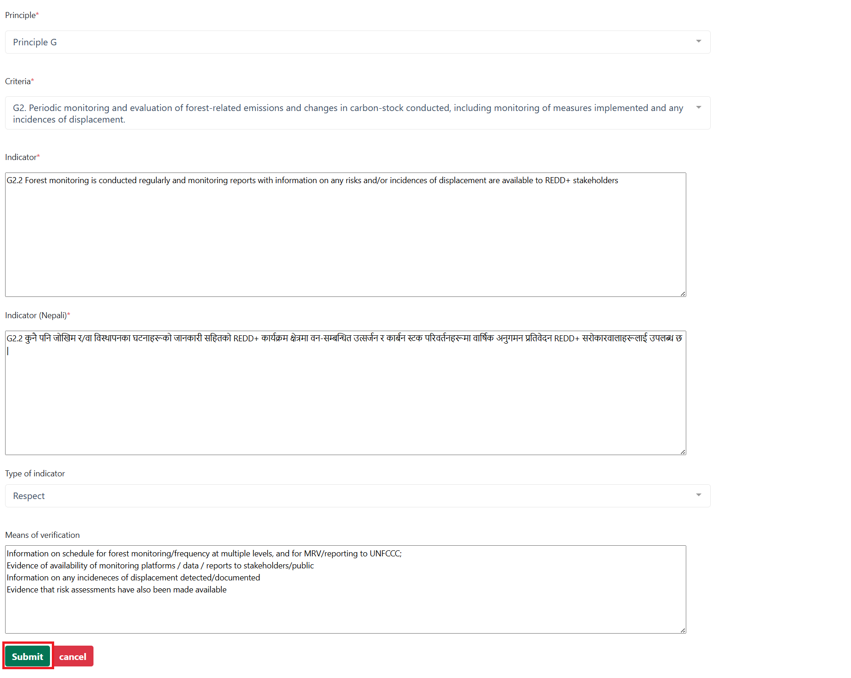

Verifier
This section enables user to add, modify and delete Verifier. DFOs create the verifier, and the provincial REDD focal person reviews and approves it. Only after approval is the verifier published.
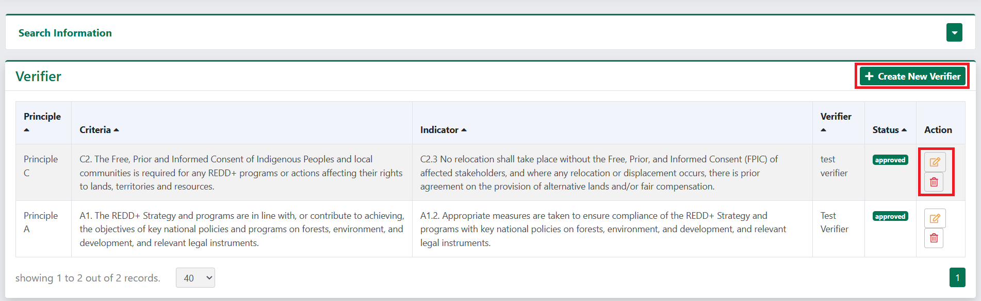
To add a new Verifier, click on create New Verifier. On doing so a form will appear in screen as shown in image below. Select the principle
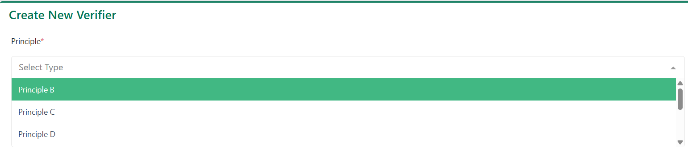
Select the Criteria.
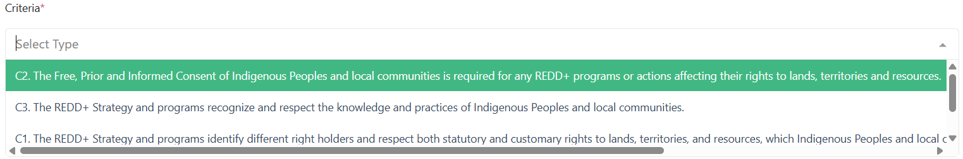
Select the Indicator.
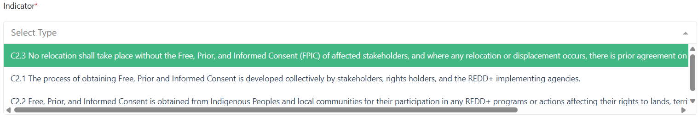

Select the Organization.
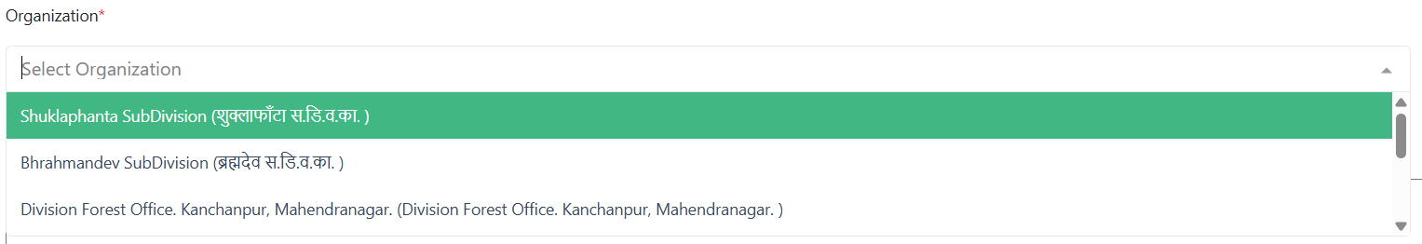
Enter the Verifier and then select the verifier type: Link, Description, or Document. The corresponding field for the chosen verifier type will be displayed accordingly.
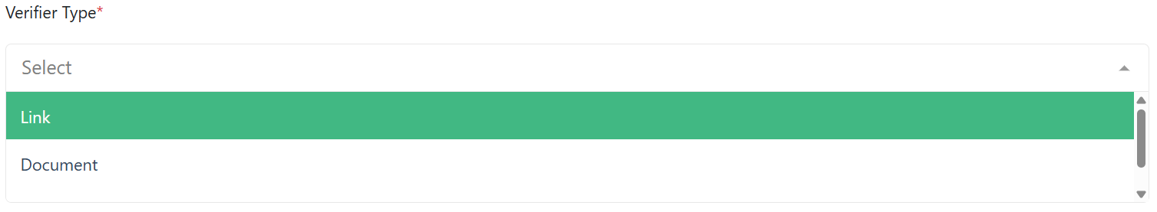
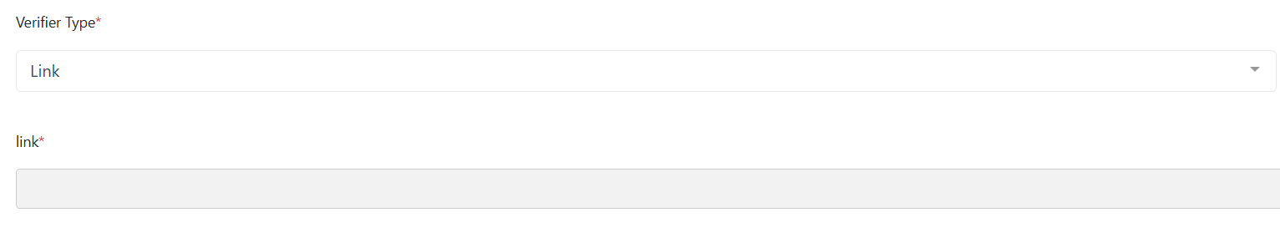
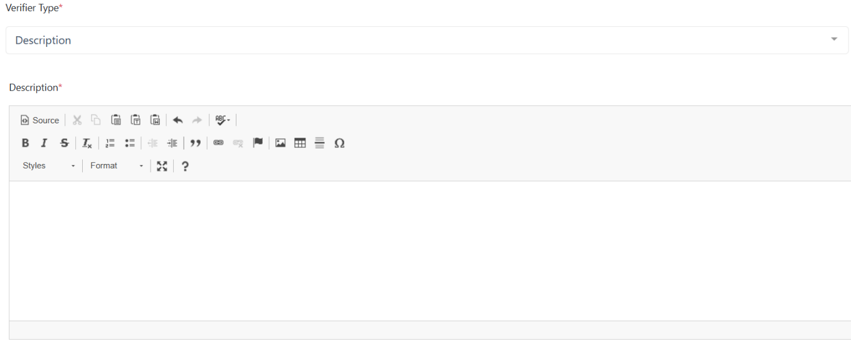
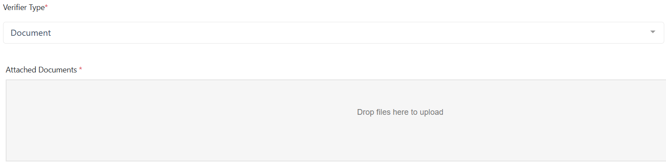
The final completed form for creating a verifier is displayed below. Click on submit button once done.
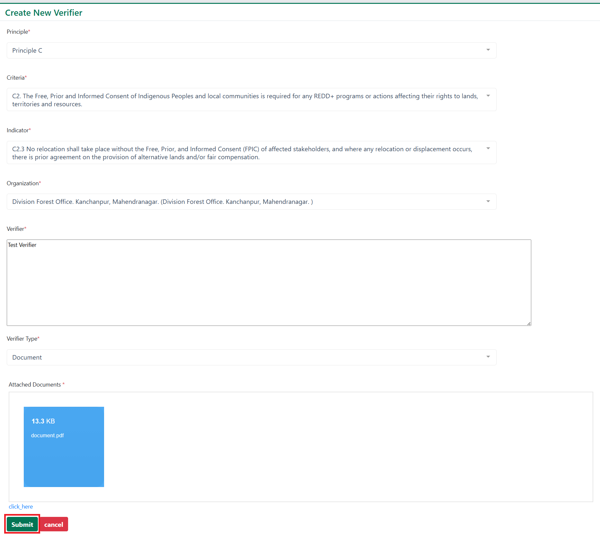
After submission, the verifier is shown in index of the DFO’s. Once a verifier is created, its status remains as "unapproved" and will not be displayed on the public system until it is approved by provincial focal person.
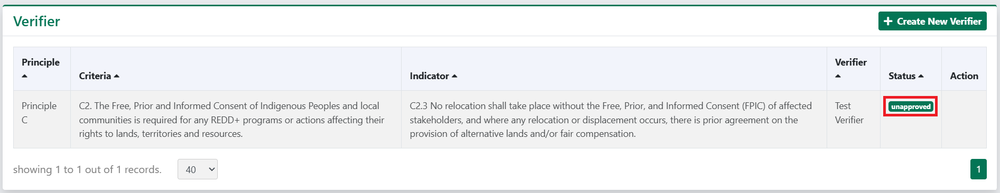
Verifier created by DFO’s are shown in the index of provincial focal person as below.
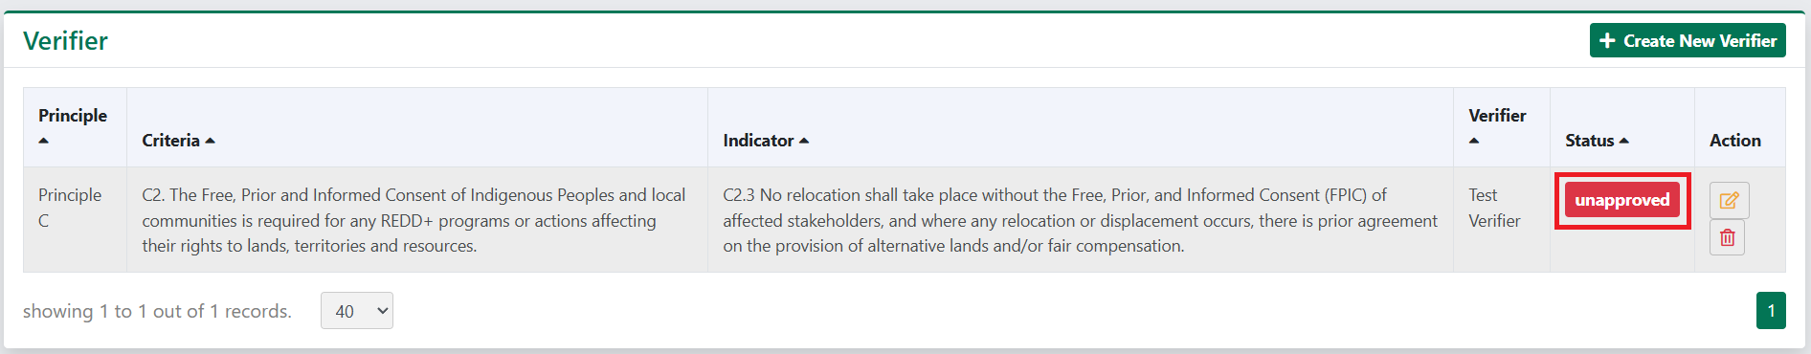
The provincial focal person opens the verifier, makes any necessary changes, and clicks on "Unapproved." The system will prompt the user to confirm if they want to approve the status of the data. By clicking "Yes," the related data will be updated to "approved" and published.
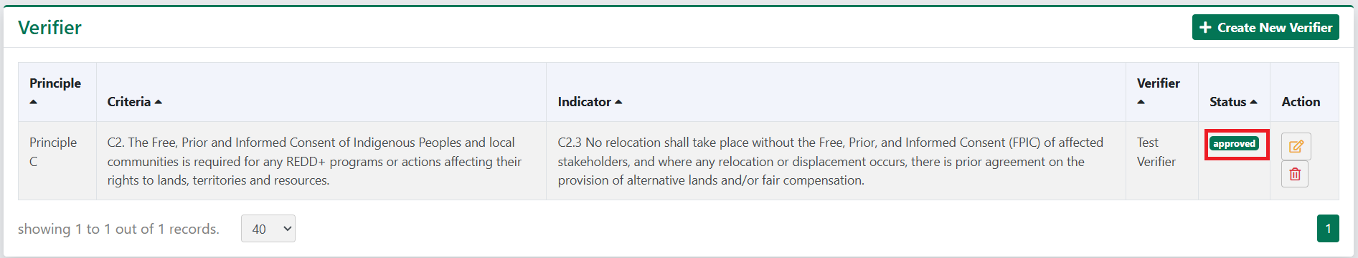

International Safeguard Policies
This section enable user to add, modify and delete International Safeguard Policies.
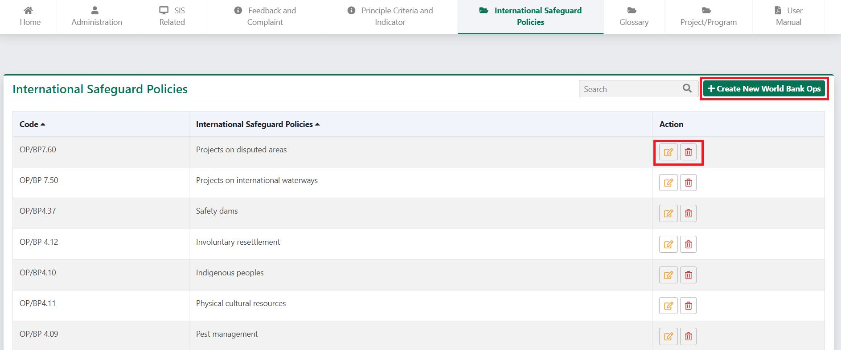
To add a new World Bank Safeguard's Policies, click on create World Bank Ops. On doing so a form will appear in screen as shown in image below. Fill the necessary information and submit the form to save the data. To modify or delete the data, click on corresponding buttons.
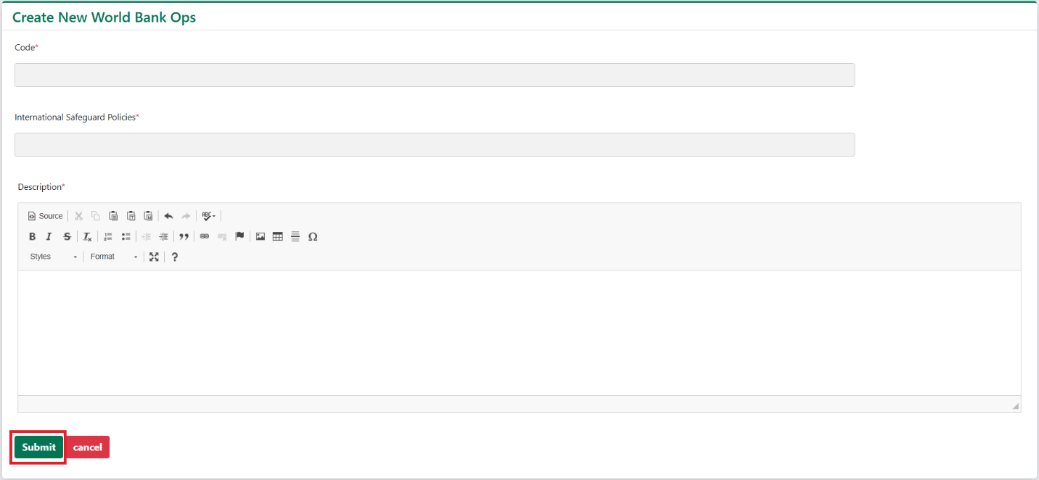

Glossary
This section enables user to add, modify and delete Glossary.
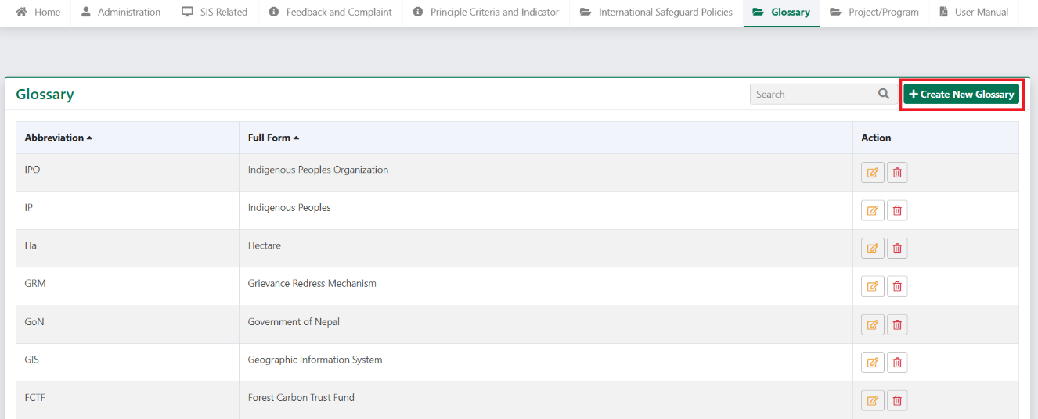
To add a new Glossary, click on create World Bank Ops. On doing so a form will appear in screen as shown in image below. Fill the necessary information and submit the form to save the data. To modify or delete the data, click on corresponding buttons.
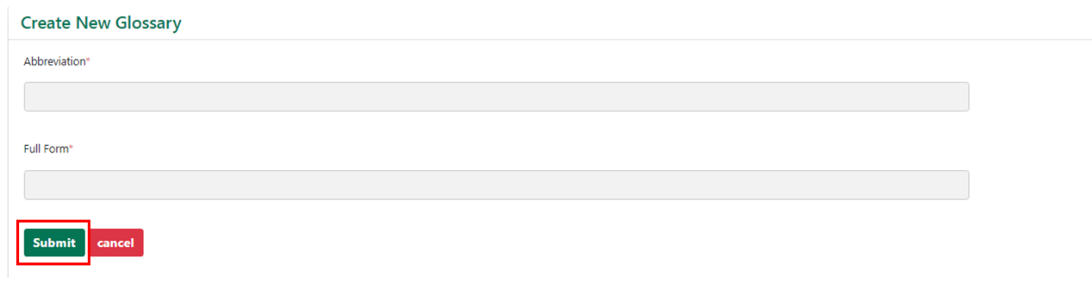

Project
This section enables users to add, modify and delete project.
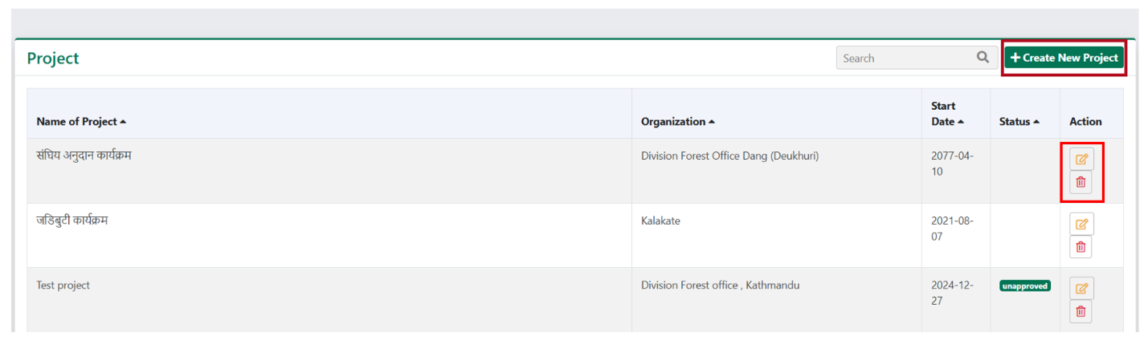
To add a new Project, click on create New Project. On doing so a form will appear on the screen as shown in image below. Fill the necessary information and submit the form to save the data.
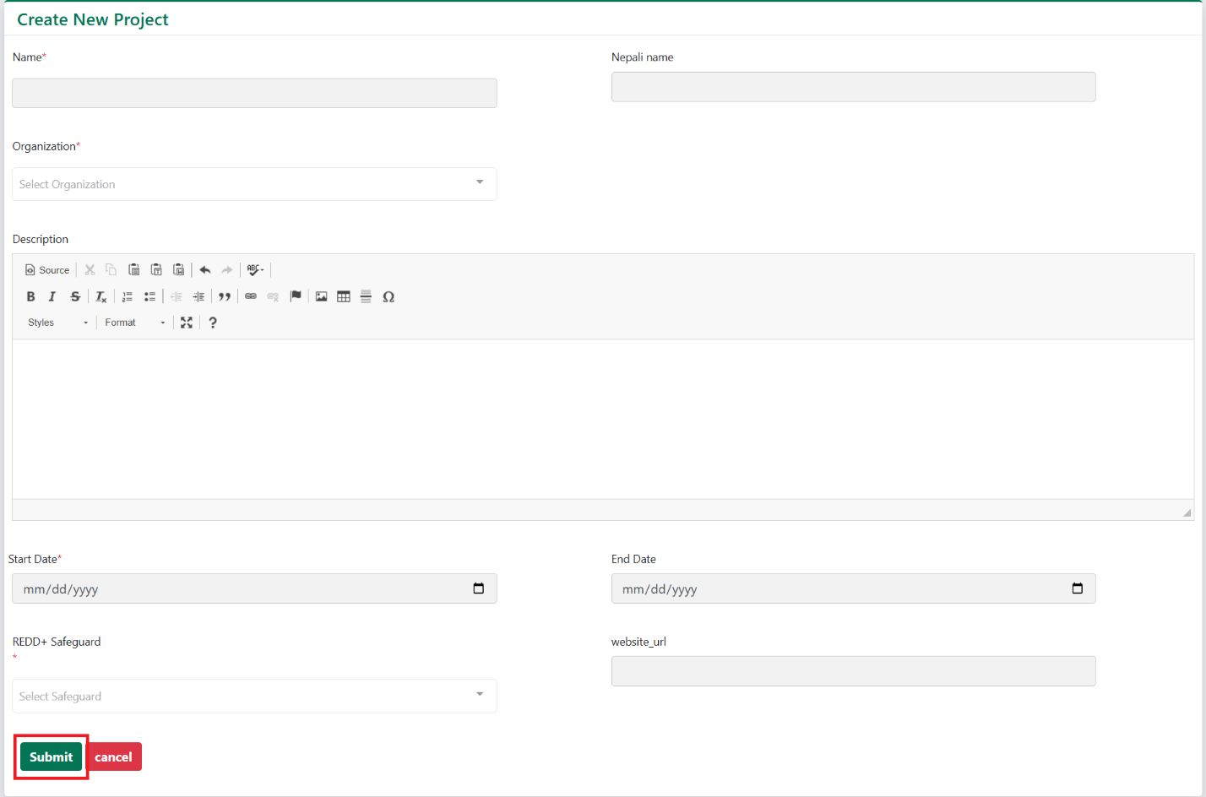
To modify or delete the old data, click on corresponding edit () and delete () buttons.

